CHAPTER ONE
INTRODUCTION
1.1 Introduction
Citizens rarely experience “the state” in the abstract; they experience it in concrete moments—when applying, verifying, waiting, resubmitting documents, or trying to understand unclear procedures. Administrative burden research shows that these encounters routinely impose learning costs (figuring out rules and eligibility), compliance costs (forms, documents, visits, time), and psychological costs (stress, uncertainty, frustration) that can influence individuals' access to services and their assessment of governmental efficacy (Moynihan, Herd, & Harvey, 2014; Heinrich, 2016). In this sense, the problem is not only inefficiency inside the bureaucracy; it is the citizen’s workload created by implementation systems (Heinrich, 2016).
Bangladesh’s push toward digital governance makes this problem especially timely. According to the evidence at a national level, there have been quantifiable gains in (i) the country’s online service offering capacity and (ii) improved standing on international indices, yet many remain fragmented and not fully end-to-end, requiring physical interaction and manual verification, which can maintain or even shift burdens without eliminating them (LightCastle Partners, 2025; Network Readiness Index, 2026). This raises a question of practicality: if citizens need to still “carry” documents and undergo hybrid processes, then e-service delivery will change the form of burden rather than minimize it.
The literature offers competing expectations about what e-service delivery does to administrative burden. On one hand, work on public-sector e-service quality suggests that digital services can improve usability and service experience when designed around citizen needs (Buckley, 2003). Related evidence explicitly frames e-service delivery as a mechanism for lowering administrative burdens by simplifying interactions and reducing administrative friction. On the other hand, empirical research on digital self-service demonstrates that digitalization can generate new burdens, particularly for vulnerable users, by increasing learning demands, compliance complexity, and psychological strain (Heggertveit, Lindgren, Madsen, & Hofmann, 2022). These findings don't cancel each other out. Instead they point to how results depend on digital services in practice and for whom they are designed. Bangladeshi studies show how the satisfaction of citizens with e-service delivery is also influenced by the real-time performance of their local government digital service system Public choice theory and trust research predict. According to data from Union Parishad's e-service performance, increased digital transparency at the grassroots level and better ICT-enabled public service result in higher levels of citizen satisfaction (Ferdous, Islam, & Das 2022). Research on Union Digital Centers in rural Bangladesh underscores the significance of accessible services for rural populations in assessing customer satisfaction in e-service (Khadiza & Ullah 2020). Unfortunately these studies rarely make administrative burden the main explanatory path between e-service quality and satisfaction. The result is a clear gap in understanding: while the story of citizen satisfaction has been developed further than the story of burden reduction, even though administrative burden theory determines that citizen costs are basic to how people interact with government (Moynihan et al., 2014; Heinrich, 2016).

1.2 Problem Statement
Public service delivery increasingly relies on digital platforms, yet citizens continue to face administrative burden—the learning, compliance, and psychological costs closely associated with accessing government services. Administrative burden is now recognized as a fundamental aspect of citizen-state relations, influencing access, equity, and user experience (Moynihan, Herd, & Harvey, 2014; Heinrich, 2016).. Evidence from studies on Bangladesh shows that e-service delivery, especially at the local government level, has increased access and citizen satisfaction. This is especially evident in Union Digital Centers and online platforms (Khadiza & Ullah, 2020; Ferdous et al., 2022). Study of a specific service like the e-passport system also shows moderate to high satisfaction attached to timeliness and transparency (Siddika et al., 2024). A close point made in the literature is that digitalization may replicate but could also aggravate administrator burdens, especially for citizens lacking sufficient digital knowledge or means, generating new learning and psychological costs (Heggertveit et al., 2022). This tension indicates that e-services hold the potential to reduce a burden but are neither automatic nor uniform.
What is insufficiently understood is how and to what extent e-service delivery reduces administrative burden in local governments like Hathazari Upazila. Also whether this reduction explains improvement in citizen satisfaction. Studies conducted in Bangladesh-focused mostly assess satisfaction outcomes. Do not regard administrative burden as explanatory mechanisms as per Khadiza & Ullah (2020) and Ferdous et al. (2022). In addition, the evidence for Hathazari Upazila is limited. Thus, citizen experiences of learning, compliance, and psychological costs are unexplored.
Considering the digital governance of Bangladesh is still expanding, while the national e-government readiness is gradually improving (LightCastle Partners, 2025; Network Readiness Index, 2026), administrative burden is unlikely to be reduced to zero. Rather, it may stay in digital forms instead. If no local-level investigation is done, then the policymakers are likely to assume that there is a burden reduction where it does not fully exist.This study addresses that gap by examining whether and how e-service delivery reduces administrative burden and improves citizen satisfaction in Hathazari Upazila.

1.3 Rationale of the Study
Bangladesh has placed digital transformation at the center of its public administration reform agenda, emphasizing online service expansion, interoperability, and citizen accessibility (LightCastle Partners, 2025; Network Readiness Index, 2026).improving efficiency while lessening the burden on citizens to access public services is reflected as greater policy goal. Administrative burden theory highlights that both manual and digital service systems might impose psychological costs on citizens regarding learning and compliance. (Moynihan, Herd, & Harvey, 2014; Heinrich, 2016). Therefore, the question of whether e-service delivery actually lessens these burdens is still empirical and not presumptive.Early public administration discussions similarly describe electronic service delivery as a shift toward ICT-supported service provision—including integrated and “one-stop” arrangements—while also noting that such shifts raise governance and democratic considerations that must be managed alongside service modernization. (Bekkers & Zouridis, 1999)
In Bangladesh’s local government context, studies reports, improved accessibility and satisfaction through Union Digital Centers and related e-service initiatives (Khadiza & Ullah, 2020; Ferdous, Islam, & Das, 2022). However, other evidence indicates that digital self-service may generate new forms of burden, particularly for citizens with limited digital literacy or resources.Overall due to digital divide(Heggertveit et al., 2022). This fact indicates an unresolved knowledge gap: the mechanism linking e-service quality, administrative burden reduction, and citizen satisfaction has not been systematically examined in specific local settings such as Hathazari Upazila. Context-specific empirical evidence remains limited.
The significance of this study lies in bridging administrative burden theory with Bangladesh’s digital governance practice. By focusing on Hathazari Upazila, it contributes localized, evidence-based insights into whether digital reforms reduce real citizen costs and enhance satisfaction,thereby informing national e-government policy with grounded empirical findings.
1.4 Objective
The study addresses two specific objectives: first, to assess whether and to what extent e-service delivery reduces learning, compliance, and psychological costs for citizens (SO1); and second, to test whether reduced administrative burden affects the relationship between e-service quality and overall citizen satisfaction (SO2). Consistent with the Literature conceptual framework, e-service quality is treated as multidimensional—covering information quality, usability/ease of use, portal features, personalization, and interface clarity—because these design attributes plausibly shape the cognitive and procedural effort citizens must expend
General Objective
To investigate the overall impact of e-service delivery on reducing administrative burdens and enhancing citizen satisfaction in public administration.
Specific Objectives
- To assess how e-service reduces administrative burden (citizen learning, compliance, and psychological costs).
- To determine whether the reduction of administrative burden affect the relationship between e-service quality and overall citizen satisfaction
1.5 Research Question
1. To what extent does e-service delivery reduce administrative burden (learning costs, compliance requirements, and psychological costs) in local government services in Hathazari Upazila?
2. How does e-service delivery influence administrative efficiency in local government service delivery in Hathazari Upazila ?
3. What is the relationship between administrative burden and citizen satisfaction in local government services in Hathazari Upazila?
4. How does reduced administrative burden, resulting from e-service delivery, effects overall citizen satisfaction?

1.6 Research Hypothesis
H1: E-service delivery has a significant negative effect on administrative burden
H2: Reduced Administrative burden has a positive effect on citizen satisfaction.
H3: E-service delivery has a significant positive effect on citizen satisfaction.
H4: Reduced Administrative burden from the e-service delivery increases citizen satisfaction.

1.7 Applied Computer Software
For an in-depth analysis of this research, the following computer software programs were employed:
✓ Statistical Package for the Social Sciences (SPSS), used for data analysis.
✓ Microsoft Word and Google docs -used for drafting and organizing the thesis.
✓ Microsoft Excel -used for drawing graphs and visualizing data.

1.8 Organization of the Study
To make it easier to understand the effect of e-service delivery on reducing administrative burden and enhancing citizen satisfaction in Hathazari Upazila, Chattogram, Bangladesh, the book is broken down into six chapters, each one coherent and integrated. The chapters are as follows:

Chapter 1 provides an introduction to the research, including prelude, problem statement, rationale of the study, research objectives, research questions, research hypothesis, applied computer software, and organization of the study.

Chapter 2 is about literature review and theoretical framework. It includes introduction, identifying and defining concepts, identifying and justifying theory, concept operationalizing , establishing conceptual framework, and identifying research gap of the study.

Chapter 3 has a detailed look at how the research was done. It elaborates on the study design and methodology, , research type selection, reasoning process, epistemological position, ontological position clarification, data collection methods, study area selection, scope of the topic and work determination, population and sample, data analysis methods, data presentation, and ethical considerations.

Chapter 4 presents and analyzes the quantitative data gathered from surveys.It covers quantitative analysis of survey data, demographic characteristics of the study participants, e-service quality and system performance, administrative burden (including learning costs, compliance requirements, and psychological costs), citizen satisfaction, and administrative efficiency and overall impact.

Chapter 5 presents and analyzes the qualitative data which is collected through structured interviews with open-ended questions. It includes introduction, introduce with respondents, thematic analysis, e-service quality and system performance, administrative burden (learning costs, compliance requirements, and psychological costs), citizen satisfaction, and administrative efficiency and overall impact.

Chapter 6 synthesizes the findings in relation to the research hypothesis and objectives. It discusses the theoretical implications of the results and concludes with a set of recommendations derived from the overall findings of the study. This chapter includes introduction, test of research hypothesis, analysis based on research objectives, conceptual implications, conclusion, recommendations, and limitations of the study.

CHAPTER TWO
LITERATURE REVIEW
2.1 Introduction
This research primarily examined the influence of e-service delivery on reducing administrative burden and enhancing citizen satisfaction. Both administrative burden and citizen satisfaction coexist within public service delivery. Therefore, firstly investigated how scholars had defined administrative burden and citizen satisfaction. After that, I reviewed previous research on e-service delivery and also its positive implications for efficiency. This analysis helps to find a way for measuring the citizens and service providers' administrative burden reduction, service efficiency, and satisfaction levels in Hathazari Upazila.

2.2 Identifying and Defining Concepts
2.2.1 E-service Delivery / E-government Service Delivery
E-government (and by extension e-service delivery) is consistently framed as the application of ICT to improve how the government provides information and services to citizens. Often with explicit reference to efficiency, convenience, and accountability. Wescott defines e-government as the use of ICT “to promote more efficient and cost-effective government, facilitate more convenient services, expand public access to information, and strengthen accountability to citizens Wescott, C. G. (2001). Zaidi and Qteishat similarly position e-government as ICT use by governments to enhance service and information quality in “efficient and cost effective ways” via online services/portals (Zaidi & Qteishat, 2012). From a public administration lens, Bekkers and Zouridis describe electronic service delivery, as ICT-supported service provision (including “one-stop shops”), while warning that the same shift can cause strain if not carefully governed (Bekkers & Zouridis, 1999). Marche and McNiven make an important conceptual distinction: e-government often centers on information and transactions, while e-governance gestures toward broader citizen–state interactions and policy reflexivity (Marche & McNiven, 2003).

2.2.2 E-service quality
Studies do not treat e-service quality as a single attribute; it is an umbrella made visible through design, content, system features and responsiveness. Buckley highlights definitional ambiguity and argues that public sector e-service quality must be understood differently from commercial contexts. Because profit motivation has little relevance and process varies considerably across public organizations (Buckley, 2003). Ancarani offers a public-sector measurement approach linking website content quality and technological complexity to public value criteria such as efficiency, effectiveness, and transparency (Ancarani, 2005). For government portals specifically, Bhattacharya, Gulla, and Gupta propose a citizen-perspective model with portal-quality dimensions; including citizen-usability, technical adequacy, security, usefulness, transparency, and comprehensive information (Bhattacharya et al., 2012). Zaidi and Qteishat propose an e-government service quality assessment framework (e-GSQA) explicitly to capture citizen evaluation of online public services (Zaidi & Qteishat, 2012).
Some studies operationalize e-service quality through specific portal features and perceived ease of use: Wirtz and Kurtz find that downloadable forms, powerful search function, full online availability of services, and perceived ease of use positively influence user satisfaction with city government portals (Wirtz & Kurtz, 2016). Chen, Shang, and Yan operationalize mobile government “interface” quality through perceived complexity, personalization, visual appeal, and information quality (Chen et al., 2024). In a non-government e-commerce setting, Çelik uses E‑S‑QUAL and E‑RecS‑QUAL to represent e-service quality (system availability, fulfilment, responsiveness, compensation, privacy, etc.), showing that not all dimensions necessarily predict satisfaction (Çelik, 2021).

2.2.3 Administrative Burden
Administrative burden refers to the various costs and demands associated with completing administrative tasks, often resulting from the implementation of policies and regulations (Moynihan et al., 2014).Moynihan, Herd, and Harvey define administrative burden as the learning, compliance, and psychological costs citizens experience in interactions with government (Moynihan et al., 2014).Herd and Moynihan extend this into a governance argument: burdens are frequently “policymaking by other means,” the hassle people experience when interacting with the government. Administrative burden is typically characterized as an individual's perception of a policy's implementation as burdensome. It can include the time and money spent on paperwork, learning eligibility requirements, and dealing with bureaucracy. This may involve straightforward issues, such as an application process that is too lengthy and complex to complete. These costs extend beyond mere paperwork to include time, effort, financial resources, and psychological stress.
The framework’s relevance to digital government is empirically underscored by performing task on digital self-service, where digitization may lower some burdens (e.g., automatic data transfers) while increasing others (e.g., forcing citizens to perform caseworker-like tasks) (Madsen et al., 2022).
The concept is also contested. Halling and Baekgaard’s systematic review identifies the growing empirical evidence that burdens are consequential and constructed, while calling for better linking between burden experiences and outcomes (Halling & Baekgaard, 2024). Daigneault argues that the classic categories overlap and may merge state actions with lived “onerous experiences,” proposing instead time, money, effort, and psychological costs (Daigneault, 2024).

2.2.4 Administrative Efficiency
“Efficiency” is used in the studies in two partially overlapping ways. First, as a reform aspiration: e-government is expected to make government more efficient and cost-effective Wescott, C. G. (2001), and improve service quality and accessibility (Bekkers & Zouridis, 1999). Second, as service performance outcomes for example timeliness, reduced visits, and streamlined processing. In Bangladesh e-passport study, “service within a definite time,” “number of visits,” and “additional payment” appear as key service effectiveness/efficiency factors indicating association with satisfaction (Siddika et al., 2024).
According to the OECD’s tax administration report, digitization is very much part of the whole performance and efficiency modernization drive in public administration these days (OECD, 2025). But focusing into the Bangladesh context, the governance literature tends to point out that these efficiency gains are often uneven in practice. It really comes down to things like institutional capacity, how competent the people running things are, what resources are available, and whether there's actual political will to make it work. For instance, Huque and Ferdous take a pretty critical view of electronic public service delivery through those e-service centres. They argue it "has not been effective as planned," mostly because of real-world constraints in communication, competence, and resources (Huque & Ferdous, 2024). The point here is that even with e-government reforms, you're still dealing with the same old problems—inefficiency, red tape, and corruption—that have always plagued service delivery in developing countries. As Siddiquee puts it, these deep-seated issues don't just disappear because you introduce a digital system (Siddiquee, 2016).
2.2.5 Citizen satisfaction
User/citizen satisfaction is treated as a key success indicator of e-government initiatives. Wirtz and Kurtz explicitly frame user satisfaction as “crucial” for success or failure of local e-government portals (Wirtz & Kurtz, 2016). Studies focused on Bangladesh passport- similarly identify satisfaction as the evaluative outcome of whether digital reforms deliver real improvements (Ahamed; Siddika et al., 2024; Hussan). Chen et al. connect satisfaction to administrative burden by demonstrating that interface qualities shape learning/psychological/compliance costs and user satisfaction (Chen et al., 2024). Wang and Ma show that digital interfaces for service evaluation can increase citizen satisfaction relative to offline channels, especially via mobile interfaces (Wang & Ma, 2022).

As For Hathazari Upazila, e-service delivery is treated as the citizen-centric access channel, while e-government/e-governance frames the broader reform agenda; however, Efficiency and satisfaction should reflect both service performance and citizen burden, acknowledging local evidence gaps evidence is absent, creating a contextual gap. Although upazila settings differ, the most transferable lenses are portal/system attributes and interface qualities that shape learning and compliance costs. Conversely, efficiency may improve administratively while shifting burdens to citizens. Nevertheless, satisfaction reflects on overall judgments shaped by both experienced burdens and service quality .
Table:1
Concept | Definition(s) in literature | Variations/contested meanings | Key references
E-service delivery / e-government service delivery | ICT-enabled delivery of government services/information to citizens, often via portals/apps, aiming at efficiency, convenience, accountability | Distinction between e-government (transactions/info) and e-governance (broader citizen–state relationship and reflexivity) | (Wescott, 2001); (Zaidi & Qteishat, 2012,); (Marche & McNiven, 2003 ); (Bekkers & Zouridis, 1999)
E-service quality | Multi-dimensional quality of online service experience: information/content quality, system/interface qualities, usability, availability, reliability, responsiveness; public-sector constraints matter | Public vs private sector differences; task complexity affects what “quality” means; not all quality dimensions predict satisfaction consistently | (Buckley, 2003); (Ancarani, 2005, ); (Bhattacharya et al., 2012, ); (Zaidi & Qteishat, 2012); (Wirtz & Kurtz, 2016); (Chen et al., 2024); (Çelik, 2021)
Administrative burden | Learning, compliance, psychological costs experienced by citizens in citizen–state interactions | Critique: learning/compliance overlap and may conflate state actions with experiences; alternative dimensions proposed (time/money/effort/psychological) | (Moynihan et al., 2014); (Herd & Moynihan, 2018; Herd & Moynihan, 2018); (Halling & Baekgaard, 2024); (Daigneault, 2024))
Administrative efficiency | Improved speed, accessibility, and cost-effectiveness of administrative processes and service delivery | Efficiency gains can be achieved by shifting work to citizens via digital self-service; risks “efficiency–burden tradeoff” | ((Wescott, 2001); (Bekkers & Zouridis, 1999); (Ancarani, 2005); (Huque & Ferdous, 2024); (Madsen et al., 2022); (Siddika et al., 2024)
Citizen satisfaction | Citizens’ evaluative judgment of service quality and experience; key determinant of e-government success | Satisfaction can be shaped directly by portal features/usability or indirectly through burden, trust, and perceived performance | ((Wirtz & Kurtz, 2016); (Chen et al., 2024); (Wang & Ma, 2022); (Siddika et al., 2024); (Rifai, 2022)

2.3 Identifying and Justifying Theory
Identifying and justifying an appropriate theory is essential for empirical inquiry and for coherent conceptual/analytical and theoretical framework. A well-selected theory not only clarifies key constructs. But also explains their relationships, thereby strengthening the study’s internal logic and interpretive validity (Creswell, 2014; Bryman, 2016).

2.3.1 Identifying Theories/models

i. Administrative burden framework (learning/compliance/psychological costs) — core formulation and “hidden politics” logic (Moynihan et al., 2014; Herd & Moynihan, 2018; Herd & Moynihan, 2018).

ii. Administrative burden in digital self-service — application in complex welfare contexts and burden redistribution (“accidental caseworker”) (Madsen et al., 2022); vulnerable citizens and frontline-worker dynamics (Heggertveit et al., 2022).

iii. Reconceptualization around onerous experiences — alternative dimensions (time/money/effort/psychological) (Daigneault, 2024).

iv. Systematic model and “burden tolerance” — review-based conceptual model and research agenda (Halling & Baekgaard, 2024).

v. Attribution theory — used to theorize how older adults interpret m-government experiences and burdens (Chen et al., 2024).

vi. Technology Acceptance Model (TAM) — perceived usefulness/ease of use as adoption logic (Davis, 1987); integrated with e-government success/digital divide framing (Rahman, 2015).
vii. E-service quality models/scales — public sector quality and measurement challenges (Buckley, 2003; Buckley, 2003 Word draft); local public service website evaluation approach (Ancarani, 2005); portal quality model for government portals (Bhattacharya et al., 2012); e-GSQA framework (Zaidi & Qteishat, 2012); E‑S‑QUAL/E‑RecS‑QUAL scales used in e-commerce (Çelik, 2021).
viii. Trust mediation — e-passport system → trust → satisfaction (Rifai, 2022).
Digital divide conceptualization — conceptual mechanisms linking divide to e-government success (Rahman, 2015) and inclusion/administrative literacy requirements (Grönlund et al., 2007).
ix. Citizen–state interaction / public encounter framing — citizen-state interaction dynamics as analytic lens (Döring, 2019).
x. New Public Management reform discourse — reform framing emphasizing performance/efficiency (Siddiquee, 2006; Bekkers & Zouridis, 1999).

2.3.2 Which theory best explains the study relationships
(i) How e-service quality affects administrative burden
Best explanatory fit: The administrative burden framework, as applied in digital self-service settings, most directly explains how system design and implementation requirements translate into learning/compliance/psychological costs. Madsen et al. show that mandatory digital self-service can increase burden because citizens must learn tasks once performed by caseworkers and comply with specific data formats and procedural demands (Madsen et al., 2022). Chen et al. empirically demonstrate that perceived complexity increases learning/psychological/compliance costs, while personalization and information quality decrease these costs (Chen et al., 2024).
Why e-service quality models still matter: E-service quality frameworks specify what aspects of the digital channel can be manipulated—information quality, usability, system availability, portal features—and these are precisely the levers that plausibly reduce learning and compliance costs (Bhattacharya et al., 2012; Wirtz & Kurtz, 2016; Zaidi & Qteishat, 2012). In other words, administrative burden provides the citizen-cost mechanism, while e-service quality provides the design vocabulary.

(ii) How administrative burden relates to citizen satisfaction
Best explanatory fit: The burden framework explicitly argues that burdens shape citizens' success accessing services and perceptions of government, implying downstream satisfaction effects (Moynihan et al., 2014). Chen et al. provide direct empirical linkage in a digital setting: burden components vary with interface qualities and are tied to user satisfaction outcomes (Chen et al., 2024). Bangladesh passport studies also indirectly support the connection by showing that satisfaction is associated with time, visits, access ease, and extra payments—indicators that map closely to compliance costs and, in some cases, psychological strain (Siddika et al., 2024; Hussan).
Caution/contestation: Daigneault challenges whether "learning" and "compliance" are cleanly separable as experiences, cautioning that measurement must reflect onerous experiences rather than state actions (Daigneault, 2024). This affects how confidently we claim a burden→satisfaction pathway unless burdens are carefully operationalized.

(iii) Where administrative efficiency fits
Best explanatory fit: Efficiency is consistently framed as a central intended outcome of e-government and e-service delivery reforms (Wescott, n.d.; Zaidi & Qteishat, 2012). However, the studies complicate a simple "digital = efficient" narrative. Digital self-service can improve administrative efficiency, but it can also place burdens on citizens (Madsen et al., 2022). In Bangladesh, Huque and Ferdous observe that e-service centers are not as effective as hoped due to problems with skills, resources, and political will. This suggesta that efficiency gains rely on how well those factors are implemented (Huque & Ferdous, 2024).
Interpretively, efficiency should therefore be treated as a parallel outcome pathway (e-service delivery → administrative efficiency), while also functioning as a contextual mechanism that may reshape administrative burden. When efficiency is achieved through increased citizen self-service, the reduction of state-side workload may correspond with a rise in citizen-side costs—time, effort, and psychological strain.

2.3.3 Best-fit Theory Choice And Justification
Chosen integrated set:
Administrative burden framework (learning/compliance/psychological costs) as the core mediating mechanism (Moynihan et al., 2014; Herd & Moynihan, 2018; Herd & Moynihan, 2018), reinforced by digital self-service recipients(applicants) (Heggertveit et al., 2022; Madsen et al., 2022; Chen et al., 2024).
E-service quality / portal quality frameworks to specify the applied features of digital delivery (Zaidi & Qteishat, 2012; Bhattacharya et al., 2012; Ancarani, 2005; Buckley, 2003; Wirtz & Kurtz, 2016).
TAM constructs (ease of use/usefulness) as supportive conceptual mechanisms for adoption and satisfaction, where explicitly invoked (Davis, 1987; Rahman, 2015; Wirtz & Kurtz, 2016; Rifai, 2022).
Digital divide / inclusion as borderline conditions shaping who benefits from burden reduction (Grönlund et al., 2007; Rahman, 2015; Heggertveit et al., 2022; Siddika et al., 2024).

2.3.4. Mechanisms (how/why the relationships occur)
Mechanism 1: E-service quality reduces learning costs by lowering "search and comprehension work."
When portals/apps are usable, searchable, and informative, citizens need less effort to understand eligibility, procedures, and what to do next. This is consistent with Grönlund et al.'s finding that in comparison of most of the 10 services, e-services reduced knowledge and skill requirements (Grönlund et al., 2007). Wirtz and Kurtz similarly show that a powerful search function and perceived ease of use contribute to satisfaction—features that plausibly lower learning costs (Wirtz & Kurtz, 2016). Chen et al. operationalize this directly:while information quality and personalization reduce them .But perceived complexity increases learning costs, (Chen et al., 2024).
Mechanism 2: E-service quality reduces compliance costs by lowering barriers to exchange—but can also shift compliance onto citizens.
Digitization can cut down visits and repetitive paperwork (a compliance cost proxy), as seen in the Bangladesh e-passport evidence where satisfaction is associated with fewer visits and timely service (Siddika et al., 2024). Yet Madsen et al. shows the "accidental caseworker" mechanism: digital self-service can increase compliance burdens by requiring citizens to follow data-format rules.And complete tasks as the professionals used to do (Madsen et al., 2022).
Mechanism 3: Psychological costs respond to both stigma dynamics and design-induced anxiety.
Eliminating the need for human interaction reduces both costs and stigma.Optical level One example of calls on social workers is Madsen et al. describe what 'explicit documentation' means for one type of such referral by highlighting its benefits. (Madsen et al., 2022).Yet psychological costs may rise when a system is uncertain or difficult to use. Chen et al. in one case, for instance, define stress/anxiety/psychological discomfort as the stress of using complex systems and find this is more than equivalent to reading a similarly dense printout (244).Moreover, in visual clarity and quality of information, they don't come true.(Chen et al., 2025)This suggests that ‘reducing burden’ is not automatic; it’s a product of design and a product of use.
2.4 Operationalizing concepts
This study aims to examine the influence of e-service delivery on administrative burden and citizen satisfaction in Hathazari Upazila, Chattogram, Bangladesh.
STEP 3: OPERATIONALIZING CONCEPTS (MEASUREMENT SYNTHESIS)
2.4.1 E-service delivery / e-government service delivery
✓ Often treated conceptually or descriptively (policy/reform orientation) rather than measured as an index (Bekkers & Zouridis, 1999; Wescott, n.d.; Siddiquee, 2016).
✓ Bangladesh local delivery is discussed through the structure of e-service centers and their functional performance claims versus observed constraints (Huque & Ferdous, 2024).
✓ Measurement gap: Few files present a direct, citizen-level measure of "extent of e-service delivery" in local government beyond usage context or reform description.

2.4.2 E-service quality
Portal/service quality models and dimensions:
✓ Government portals: multi-dimensional constructs (Bhattacharya et al., 2012; Zaidi & Qteishat, 2012).
✓ City portals: specific features (forms, search, full online availability) and Perceived Ease of Use (Wirtz & Kurtz, 2016).
✓ Mobile government: perceived complexity, personalization, visual appeal, information quality (Chen et al., 2024).
Scale-based measurement:
✓ E‑S‑QUAL/E‑RecS‑QUAL used in e-commerce (system availability, fulfilment, responsiveness, compensation, etc.) and tested via CFA/SEM (Çelik, 2021).
✓ Public sector quality measurement challenges:
✓ Emphasis on task complexity and "conditions of success" rather than a single universal scale (Buckley, 2003).

2.4.3 Administrative burden (learning, compliance, psychological)
✓ Survey/SEM measurement: Chen et al. provide a clear operationalization of learning cost (e.g., needing to continuously learn/adjust), psychological cost (stress/anxiety/discomfort), and compliance cost (complex rules, additional time to understand guidelines), using a 1–5 agreement scale and SEM testing (Chen et al., 2024)

Qualitative operationalization:
The learning and compliance tasks of citizens in a kind of process (Madsen et al., 2022). In process models benefit applications down telephone lines and machines; not only the poor have to do caseswork tasks, yet can put them in line for reprimand. Compounding this, online information transfer as well as automatic data transfer down helps decrease backbreaking process procedures to some extent by reducing degree work. In fact most things like renaming firm and so forth are top priority affairs (Madsen et al., 2022).

The burdens of vulnerable people in digital welfare applications; front line workers both reduce and add to burdens (Heggertveit et al., 2022).Proxy operationalization / outcome-based indicators:
Heinrich uses interruptions / disconnections in grant receipt linked to rules and requirements as a measure of the administrative burden imposed on individuals or organizations (2016).
Ntaliani & Costopoulou discuss the measurement of administrative burden for rural businesses and other small firms (Ntaliani & Costopoulou, 2017).
Studies of satisfaction for the Bangladesh passport issue use as practical burden indicators time spent, number of visits and extra money paidZhongping (Siddika et al., 2024).

2.4.4 Administrative efficiency

✓ Often operationalised indirectly by such indicators as time-to-service, reduced visits, streamlined procedures (Siddika et al., 2024; Ancarani, 2005).
✓ OECD provides a comparative administrative performance/modernization framework and digital elements for efficiency in tax administration (OECD, 2025).
✓ Bangladesh delivery assessments stress implementation constraints rather than standardized efficiency metrics (Huque & Ferdous, 2024; Siddiquee, 2016).

2.4.5 Citizen satisfaction
✓ Measuring this is done using a general measure for how satisfied people were with the internet introduced by Wirtz and Kurtz (2016).
✓ In an Electronic passport sample in the Bangladesh study, users' satisfaction index is dependent on service convenience, time consumed, number of times calling for service and additional payments it makes. Principle component analysis (EFA) has produced something akin to service efficiency and administrative support components (Siddika et al., 2014).
✓ In Rifai's study, citizen satisfaction is modeled as a dependent variable and the mediating effect of trust tested (Rifai, 2022).
✓ Citizen satisfaction is treated as an outcome and compared with an offline evaluation by Wang and Ma (Wang & Ma, 2022).

2.4.6 Effect evidence in the literature
Direct Effects (e-service quality → administrative burden → citizen satisfaction): The literature evidence contains strong conceptual plausibility and partial empirical linkage (Chen et al., 2024, ), but the literature does not clearly provide a dedicated effect test where administrative burden is explicitly modeled as the mediator between e-service quality and satisfaction.

Effects in related pathways: Rifai explicitly tests mediation (trust effects relationships from perceived ease/practicality to satisfaction) using PLS (Rifai, 2022, F23). This shows that effects testing is methodologically feasible in digital service studies, but the mediator differs from administrative burden.
Table:2 :Operationalization table
Construct | Indicators/measures (as use in Literature ) | Data source | Level of analysis | Strengths/limits | Key file(s)
E-service delivery | Structural presence/operation of e-service centers; reform description; usage context | Secondary review; descriptive evidence | System/organizational | Useful for context; weak for citizen-level causal inference | ((Huque & Ferdous, 2024); (Siddiquee, 2016)
E-service quality | Portal dimensions (citizen-centricity/usability/security/info completeness); e-GSQA framework; portal features (forms/search/full online availability); perceived ease of use; interface qualities (complexity/personalization/visual appeal/info quality); E‑S‑QUAL dimensions | Surveys; conceptual models; website assessment approach | Citizen evaluation / portal level | Strong conceptual coverage; public sector task complexity complicates “one scale fits all” | (Bhattacharya et al., 2012); (Zaidi & Qteishat, 2012); (Wirtz & Kurtz, 2016); (Chen et al., 2024); (Çelik, 2021); (Buckley, 2003)
Admin burden: learning costs | Items like continuous learning/adjustment; administrative literacy/knowledge/skills requirements; qualitative burdens along service process | Surveys; comparative service analysis; interviews | Citizen | Directly aligned with burden framework; learning items may overlap with compliance/effort | (Chen et al., 2024); (Grönlund et al., 2007); (Madsen et al., 2022)
Admin burden: compliance costs | Items about complex rules, extra time, unnecessary requirements; number of visits/time/extra payments as practical proxies; qualitative tasks shifted to citizens | Surveys; mixed methods; interviews | Citizen | Proxies capture real friction but risk missing “hidden” compliance work | (Chen et al., 2024); (Siddika et al., 2024); (Madsen et al., 2022)
Admin burden: psychological costs | Stress/anxiety/discomfort; stigma and autonomy issues; anonymity reducing stigma | Surveys; interviews | Citizen | Captures lived experience; measurement sensitive to context | (Chen et al., 2024); (Madsen et al., 2022); (Moynihan et al., 2014)
Administrative efficiency | Timely service; fewer visits; efficiency/effectiveness/transparency criteria; modernization indicators in administration | Surveys; website quality approach; comparative report | Citizen + system | Often indirect; needs clearer local-government indicators | (Siddika et al., 2024); (Ancarani, 2005); (OECD, 2025)
Citizen satisfaction | Overall satisfaction; portal satisfaction; satisfaction linked to service access ease/time/visits; satisfaction modeled with trust | Surveys + regression/SEM/PLS; mixed methods | Citizen | Strong as outcome; causal ordering often inferred rather than proven | (Wirtz & Kurtz, 2016); (Chen et al., 2024); (Siddika et al., 2024); (Rifai, 2022); (Wang & Ma, 2022)

2.5 Conceptual Framework
Proposed framework (aligned with SO1 and SO2)
2.5.1 Narrative explanation
Drawing from administrative burden theory (Moynihan et al., 2014; Herd & Moynihan, 2018) and digital self-service evidence (Madsen et al., 2022; Chen et al., 2024), the framework proposes that e-service quality shapes citizen experience by changing the costs of interaction:
✓Better information quality, personalization, usability/searchability, and interface clarity reduce learning costs (Grönlund et al., 2007; Chen et al., 2024; Wirtz & Kurtz, 2016).
✓ Streamlined processes and fewer required steps/visits reduce compliance costs, though mandatory self-service can increase them if work is shifted to citizens (Madsen et al., 2022; Siddika et al., 2024).
✓ Reduced stigma/anxiety and clearer guidance reduce psychological costs, while confusing systems increase stress (Madsen et al., 2022; Chen et al., 2024).
Reduced administrative burden should, in turn, improve citizen satisfaction, consistent with the burden framework's emphasis on citizen experience and Chen et al.'s empirical model linking burdens and satisfaction (Moynihan et al., 2014; Chen et al., 2024).
Administrative efficiency is included as a parallel and partially overlapping pathway: e-services aim to improve efficiency (Wescott, n.d.), and in practice efficiency is visible to citizens through time-to-service, number of visits, and reduced hassle (Siddika et al., 2024). Yet efficiency can be achieved by shifting work to citizens (Madsen et al., 2022), making it empirically important to measure efficiency and burden together rather than assuming they move in the same direction.

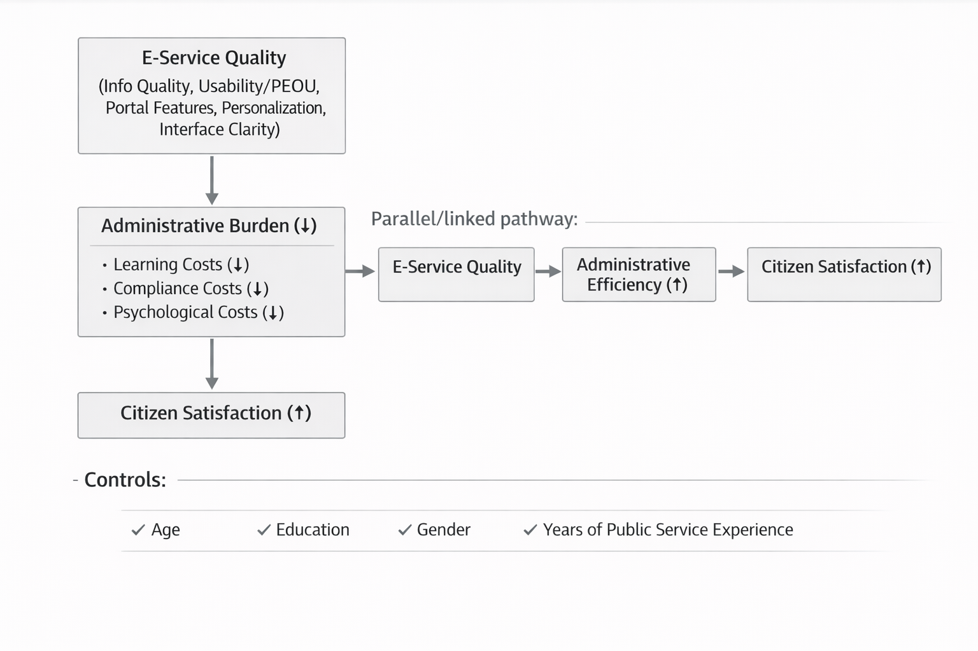

Diagram 1 :Conceptual Framework

2.5.2 variable list
Independent variable (IV): E-service quality
✓ Candidate dimensions : information quality, usability/ease of use, availability of full online service, portal features (search/forms), personalization, interface clarity/visual appeal

Mediator: Administrative burden reduction
✓ Learning costs, compliance costs, psychological costs

Dependent variable (DV): Citizen satisfaction
✓ Overall satisfaction with local e-services

Administrative efficiency (positioned as parallel pathway/outcome):
✓ Timeliness, number of visits, process speed, perceived efficiency

Controls:
✓ Age,education,Gender,Years of public service experience,

2.6 Identifying Research Gap-
Positioning a study within the existing body of knowledge is impossible without identifying the research gap. It involves systematically examining prior literature to uncover conceptual, methodological, or contextual limitations that warrant further investigation. (${seealso:c; also see =to be greater and better}, 2016).

2.6.1 Primary Gap Question and Sub-questions
Primary Gap Question:
How, and through which administrative burden dimensions (learning, compliance, psychological), does e-service quality translate into citizen satisfaction in an upazila-level local government context?
Sub-questions aligned with RQ :
- Which aspect of e-service quality (information quality, usability/ease, portal features, personalization/interface clarity) most strongly predicts learning, compliance, and psychological costs in local services?
- Does perceived administrative efficiency (time, visits, service speed) move in tandem with burden reduction—or do citizens experience an efficiency–burden tradeoff?
- Is administrative burden a statistically significant effect between e-service quality and citizen satisfaction in a Bangladesh local government setting (currently under-tested in the literature )?
- Do education, age, and digital divide conditions moderate the pathway from e-service quality to burden reduction and satisfaction?

2.6.2. Synthesis Conclusion (what we know, what we don’t, what your framework enables)
Taken together, these conclusions are speculative and sparse but sensibly fall.The administrative burden framework gives a new language in this carefully delineated translation by distinguishing learning expenses, compliance outlays, and psychological costs of participation (Moynihan et al., 2014; Herd & Moynihan, 2018). On the digital self-service side, studies show the central contradiction: while there may be less of a load whose weight is not perceived if there is less information to take in and communicate online with others about one's situation than does occur now-face-to-face encounters are more demanding than directly searching for relevant material going through self-help forums, and rigid scripting within mandatory large Web applications (Madsen et al., 2022; Heggertveit et al., 2022). As for the quality of e-service side, portal and interface features--searchability, usability/ease-of-use, information quality, personalization--have persistent statistical appearances in any quality assessment as important ingredients toward better user outcomes (Wirtz & Kurtz, 2016; Bhattacharya et al., 2012; Chen et al., 2024).
The issue remaining, therefore, is whether in performance appraisal terms it may be taken for granted that the management of administrative burden is a go-between for high-quality e-service and consensus satisfaction in Bangladesh's local government level. Satisfactions patterns and service frictions are evident in these studies of Bangladesh passports and local government, however often burden is captured merely obliquely (Siddika et al., 2024; Ferdous et al., 2022). So as not to be taken as abstract model construction exercises, but rather to allow for a verifiable account of what makes e-services work or not work on the citizen level - just the place the critics keep saying it's missing from the review (Halling & Baekgaard, 2024).

CHAPTER THREE
METHODOLOGY
3.1 Introduction
Objectives of the study The objective of this research was to investigate and to understand the effect of e-services delivery on reduction in administrative burden and increase in satisfaction level among citizen at Hathazari Upazila, Chattogram, Bangladesh. As the research concentrated on dimensions of e-service that impact positive effect by diminished administrative burden and satisfaction among citizens in the public administration, and then relationship between e-service quality and overall citizen satisfaction, an integrated strategy to research was utilized. The integration of results from different methods allowed for a richer and more comprehensive understanding of the results than using any one single method alone (Heale & Forbes, 2013), leading to the rise in popularity of mixed-method studies throughout the 1980s (Maxwell, 2016).

3.2 Study Design and Methodology
A mixed methods study is defined as collecting and analyzing data with both quantitative and qualitative methods, so as to better understand the defining problems. (Creswell,1999). In the mixed-method approach, quantitative (survey) and qualitative (semi structured interviews through open-ended questions) data were examined together. To execute quantitative insights, the researcher utilized an institution-based cross-sectional survey to assess the extent to which e-service delivery reduces administrative burden (learning costs, compliance requirements, and psychological costs), examine how this reduction influences administrative efficiency in local government service delivery, and explore the relationship between administrative burden and citizen satisfaction among citizens who utilize e-services in Hathazari Upazila. In addition, structured interviews with open-ended questions were conducted in order to collect qualitative insights into citizens ' and service providers ' views on the general public's satisfaction with e-service delivery as a result of reduced administrative burdens. By this method intrinsic non-numeric data was mined and running thought has been made in the wave for the main persons in terms of informing them how it is necessary to deal with e-service delivery and the implications of it as well. This study 's overall goal was that due to the large number of beneficiaries, activities were directed in this direction on the basis of selecting a small number for running studies.

3.3 Research type selection
Selected type: Explanatory with an embedded exploratory component.
The explanatory component fits the goal of testing directional hypotheses and mediation relationships. The exploratory component is justified because Bangladesh local-government e-service studies in the literature operational frictions and context-specific constraints that require interpretive exploring .

3.4 Reasoning Process
The predominant reasoning is deductive, although it is also impacted by inductive qualitative reasoning. Hypothesis testing with known constructs (burden dimensions; service quality; satisfaction) requires deduction. Induction must be employed so as to allow for the evolution of local patterns of burden and coping. Notably, Madsen et al. notably characterize analysis as both deductive (administrative burden as lens) and inductive (themes emerge), giving value to this hybrid reasoning choice (Madsen et al. 2022).

3.5 Epistemological position selection
Selected position: Critical realist.
This is chosen because the study treats administrative burden as a real set of costs produced through institutional design and service processes while also recognizing that the primary access to those costs is through citizens’ reported experiences and interpretations. A fuller philosophical definition of critical realism is not provided in the literature .

3.6 Ontological position clarification
Ontological preference: Stratified realism about service experiences.
The study assumes that service processes and burdens exist as structured realities (rules, steps, documentation demands), but they become analytically visible through citizens’ lived experiences (learning effort, stress, compliance work) (Moynihan et al., 2014, F4; Daigneault, 2024, F3). This aligns with the literature move toward understanding burden as “onerous experiences” rather than purely administrative design (Daigneault, 2024, F3).

3.7 Data Collection Methods
Quantitative data collection:
The primary quantitative source is a citizen survey administered through both online and face-to-face modes among e-service users in Hathazari Upazila. The questionnaire includes Likert-scale items measuring e-service quality, administrative burden dimensions, administrative efficiency, and satisfaction.

Qualitative data collection
Qualitative evidence was collected through open-ended survey questions included in both the citizen questionnaire and the officials’ questionnaire.Officials data collected by in person interview and phone calls (8-10 minutes). Citizen open-ended responses capture service experiences, difficulties, confusing steps, reasons for office visits, and improvement suggestions. Officials’ open-ended responses capture implementation barriers, recurrent citizen difficulties, operational constraints, and recommendations for system improvement. This design supports triangulation between demand-side and supply-side perspectives.

3.8 Study Area Selection
Selected area: Hathazari Upazila, Chattogram, Bangladesh.
The literature supports selecting the upazila level because Bangladesh’s administrative structure includes district, sub-district (upazila), and union tiers and e-service centers operate across these tiers.

3.9 Scope of the Topic and Work Determination
Included scope:
Citizen-facing local government e-services accessed through sub-district (upazila) and union-level delivery arrangements and interfaces
Outcomes: perceived e-service quality, administrative burden (learning/compliance/psychological), administrative efficiency (citizen-visible), and citizen satisfaction
Excluded scope:
Purely national-level policy analysis of e-government reform without citizen-level measurement
Business-facing e-government burden measurement (e.g., rural businesses) except as conceptual support

3.10 Population and Sample
Population
The target population comprises citizens in Hathazari Upazila who have used local government e-services through online portals, mobile interfaces, or service centers. For the institutional perspective, the study includes officials involved in e-service delivery and related administrative processes.
Sampling frame selection
Preferred sampling frame: Service recipient on-site user recruitment. And through the closed ended question.
Sample size
The achieved sample included citizens (n = 102) and officials (n = 13), providing both user-level and implementation-level evidence for triangulated analysis.

3.11 Data Analysis Methods
Quantitative Analysis
Quantitative analysis used descriptive statistics (frequencies, means, standard deviations) and composite index construction for key constructs: e-service quality, administrative burden (learning/compliance/psychological), administrative efficiency, and satisfaction. Hypotheses were tested using regression models:

ESQ → Administrative burden (H1)
Administrative burden → Satisfaction (H2)
ESQ → Satisfaction (H3)
Mediation (H4) was examined through an indirect-effect framework using bootstrapped confidence intervals consistent with a Model 4 mediation structure.

Qualitative Analysis
Qualitative analysis followed thematic analysis. Initial codes were developed using a deductive framework based on administrative burden dimensions, while remaining open to inductive themes emerging from the data. Codes were then organized into categories and consolidated into themes aligned with the research questions and quantitative results.

Survey Instrument and Measurement Procedure
All close-ended items were measured using a five-point Likert scale. Responses were coded numerically from 1 to 5 to enable index construction and regression analysis. Where items were directionally positive (e.g., statements reflecting reduced burden), reverse coding was applied so that higher burden index values consistently indicated higher administrative burden. Composite indices were constructed by averaging relevant item scores for each construct. Reliability of multi-item constructs was assessed using internal consistency procedures prior to hypothesis testing.

Model Specification for Hypothesis Testing and Mediation
Hypothesis testing was conducted using regression-based models. The first model estimated the effect of e-service quality on administrative burden (H1). The second model estimated the relationship between administrative burden and citizen satisfaction (H2). The third model estimated the direct effect of e-service quality on citizen satisfaction (H3).

To test mediation (H4), the study examined whether administrative burden transmits part of the effect of e-service quality on satisfaction. This requires estimating:
a-path: ESQ → Burden
b-path: Burden → Satisfaction (controlling ESQ)
c-path: ESQ → Satisfaction (total effect)
c′-path: ESQ → Satisfaction (direct effect controlling Burden)
The indirect effect (a×b) was evaluated using bootstrapped confidence intervals.

3.12 Data Presentation Tools Selection
Quantitative presentation
Quantitative findings are presented using frequency tables for demographics and service-use patterns; mean ± SD tables for construct indicators; and model summary tables for regression and mediation. Graphical presentations include bar charts (item means, dimension comparisons), pie charts (key categorical distributions), and model diagrams and confidence interval plots for mediation reporting.

Qualitative presentation
Qualitative findings are presented through theme-based narrative synthesis supported by anonymized quotations, alongside thematic mapping that links themes to administrative burden dimensions and research questions.

3.13 Ethical Considerations
This study adhered to ethical research principles to ensure the protection of participants' rights and privacy. Informed consent was obtained from all participants before their involvement in the study. Participants were fully informed about the purpose, procedures, and potential implications of the research.To maintain confidentiality and anonymity, all collected data were securely stored and used exclusively for research purposes. Personal identifiers were removed or anonymized to protect participants' privacy. Additionally, participants were assured of their voluntary participation, meaning they had the right to withdraw from the study at any stage without any consequences.

CHAPTER FOUR
FINDINGS AND ANALYSIS
4.1 Introduction
This chapter presents the quantitative findings generated from two complementary survey datasets collected in Hathazari Upazila. The first dataset captures citizens’ service-use experiences (N = 102) and provides the primary evidence for the study’s core relationships—specifically, how perceived e-service quality relates to administrative burden and, in turn, to overall citizen satisfaction. The second dataset draws on officials’ responses (N = 13) and is used as a supply-side lens to validate and interpret the citizen results, particularly around operational capacity, process simplification, and administrative efficiency.
In practical terms, the citizens’ survey is treated as the main conceptual base for testing the direction and strength of the pathways (E-service Quality → Administrative Burden → Citizen Satisfaction), while the officials’ survey adds contextual depth on what is feasible in day-to-day implementation and where bottlenecks remain. The chapter is structured as follows: Section 4.2 explains the quantitative analysis approach; Section 4.3 profiles citizens and officials; Sections 4.4–4.6 report findings on e-service quality, administrative burden, and satisfaction; and Section 4.7 synthesizes results around administrative efficiency and overall impact.
4.2 Quantitative Analysis of Survey Data
4.2.1 Data sources and sample sizes
Two primary datasets were used in this chapter. The citizen survey includes 102 respondents who reported recent experiences with local government e-services in Hathazari Upazila. The officials’ survey includes 13 service providers/administrators working at Upazila and Union levels. Who reported on operational conditions, citizen-facing challenges, and efficiency effects of e-services.
4.2.2 Measurement and coding
All closed-ended survey items were coded on a 5-point Likert scale (1 = lowest agreement/most negative perception; 5 = highest agreement/most positive perception), with reverse-coding applied where needed to ensure consistent directionality of indices. In particular, items phrased positively in relation to reduced burden were reverse-coded so that higher values uniformly indicate higher administrative burden for the burden indices.
Constructs were operationalized through composite indices based on relevant item sets: (i) e-service quality (citizen dataset), (ii) administrative burden, measured through learning, compliance, and psychological cost dimensions (citizen dataset), (iii) citizen satisfaction (citizen dataset), and (iv) administrative efficiency indicators drawn from both datasets where conceptually comparable items existed.
4.2.3 Analytical techniques
The analysis proceeded in four steps. First, descriptive statistics (frequencies, means, and standard deviations) were used to summarize respondent characteristics and item responses. Second, internal consistency for multi-item indices was assessed using Cronbach’s alpha. Third, bivariate association patterns were examined using correlation analysis. Finally, regression modelling was used to test the hypothesized relationships among e-service quality, administrative burden, and citizen satisfaction, including mediation testing where applicable. Given the small officials’ sample size, officials’ quantitative results are reported primarily through descriptive distributions and role/context profiling rather than inferential modelling.
4.2.4 Missing data and assumptions
Across the datasets, missingness is concentrated in open-ended questions, which is typical in mixed-format surveys. The core Likert-scale blocks used for index construction and quantitative modelling are largely complete, supporting stable estimation of descriptive and regression results. Where minor non-response occurs, analyses are based on available cases for the relevant items.
4.3 Demographic Characteristics of the Study Participants
4.3.1 Citizens’ demographic profile
Table 4.1 summarizes the socio-demographic profile of citizen respondents (N = 102) and their self-reported frequency of using government e-services in the past six months. Overall, the sample is dominated by younger service users and comparatively higher educational attainment, which is consistent with the expectation that digitally mediated services are more frequently used by groups with greater digital exposure. This profile should be kept in view when interpreting the results, particularly in relation to learning costs and perceived ease of use.
Table 4.1: Demographic Profile of Citizen Respondents (N = 102)
Variable | Category | n | %
Age group | A. 18–25 | 49 | 48.0
 | B. 26–35 | 31 | 30.4
 | C. 36–45 | 15 | 14.7
 | D. 46–60 | 7 | 6.9
Gender | B. Female | 57 | 55.9
 | A. Male | 45 | 44.1
Education | B. Bachelor’s Degree | 38 | 37.3
 | C. Master’s Degree | 37 | 36.3
 | A. High School | 15 | 14.7
 | College | 12 | 11.8
Occupation | Student | 53 | 52.0
 | Business owner/Self-employed | 19 | 18.6
 | Homemaker | 13 | 12.7
 | Government employee | 7 | 6.9
 | Private sector employee | 6 | 5.9
 | Unemployed | 2 | 2.0
 | Other | 2 | 2.0
E-service use (past 6 months) | B. Rarely | 34 | 33.3
 | C. Sometimes | 29 | 28.4
 | A. Never | 25 | 24.5
 | D. Often | 12 | 11.8
 | E. Always | 2 | 2.0
Note: Percentages are calculated within the citizen sample (N = 102) and may not sum to exactly 100% due to rounding.
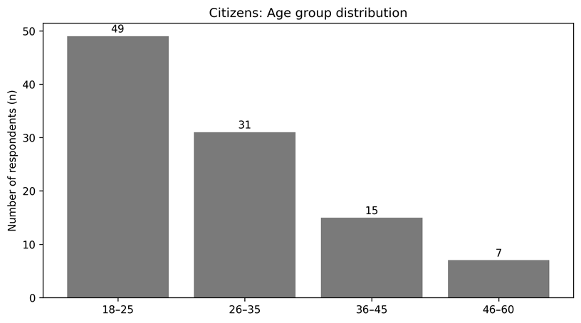
Figure 1. Citizens: Age group distribution (n shown).

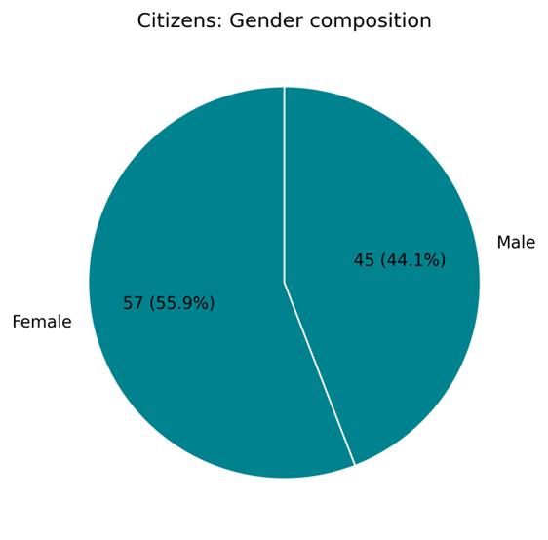
Figure 2. Citizens: Gender composition (n and % shown).

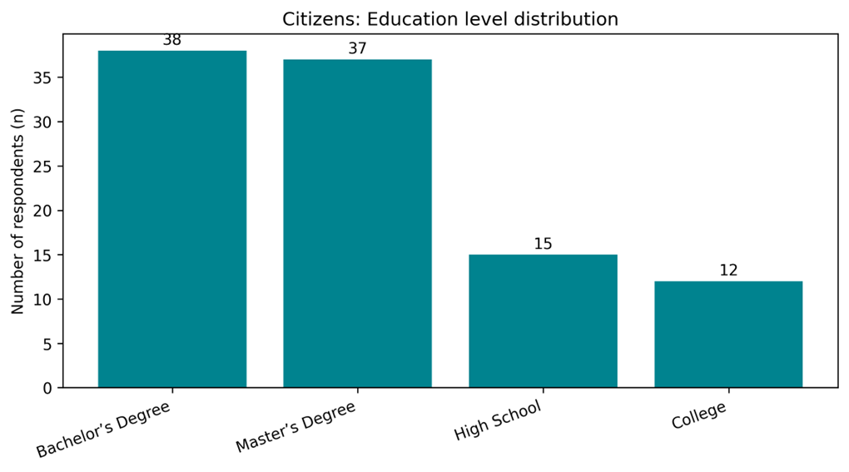
Figure 3. Citizens: Education level distribution (n shown).

Figure 4. Citizens: Occupation distribution (n shown).
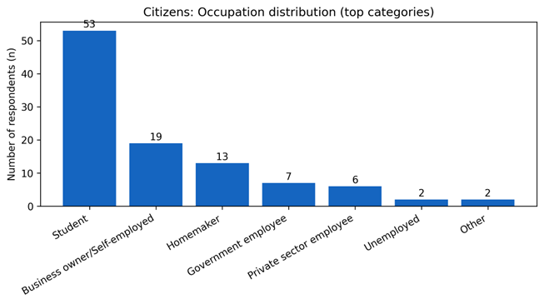
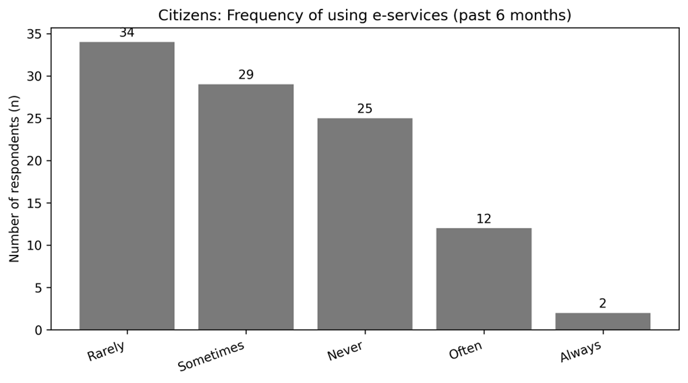
Figure 5. Citizens: E-service use frequency (n shown).

4.3.2 Officials’ role and service context profile
To complement the citizen results, Table 4.2 profiles the officials who participated in the provider-side survey (N = 13). This distribution clarifies whose operational experiences are reflected in the supply-side evidence—particularly institutional level, years of service, training exposure, and estimated weekly service load. These characteristics are important for triangulation: officials with longer service experience and higher weekly workloads are positioned to comment credibly on whether e-services are simplifying processes in practice, and whether citizen-facing burden points are diminishing or merely shifting in form.

Table 4.2: Officials’ Professional Profile and Service Context (N = 13)
Profile dimension | Category | n | %
Role/designation | B.Secretary | 7 | 53.8
 | Other | 2 | 15.4
 | C. Administrative Officials | 2 | 15.4
 | UDC Entrepreneur | 2 | 15.4
Institution level | B. Union | 10 | 76.9
 | A. Upazila | 3 | 23.1
Years of service | E. 21+ years | 5 | 38.5
 | C. 7-15 years | 4 | 30.8
 | D. 16-20 years | 3 | 23.1
 | B. 1-6 years | 1 | 7.7
ICT/e-service training | A. Yes | 9 | 69.2
 | B. No | 4 | 30.8
Requests handled per week | 26–50 | 5 | 38.5
 | 11–25 | 4 | 30.8
 | 51+ | 2 | 15.4
 | Varies/Not specified | 2 | 15.4
Note: Officials also reported handling multiple service types. The most frequently mentioned e-services were: Birth certificate (n=9); Death certificate (n=6); Testimonial/Citizenship/Character certificate (n=5); e-Nothi (n=2); Correction services (n=1); Job information (n=1); Social safety net/Disability benefits (n=1). Because officials could list up to three services, counts in this note represent mentions rather than mutually exclusive categories.

Figure 6. Officials: Role/designation (n shown).
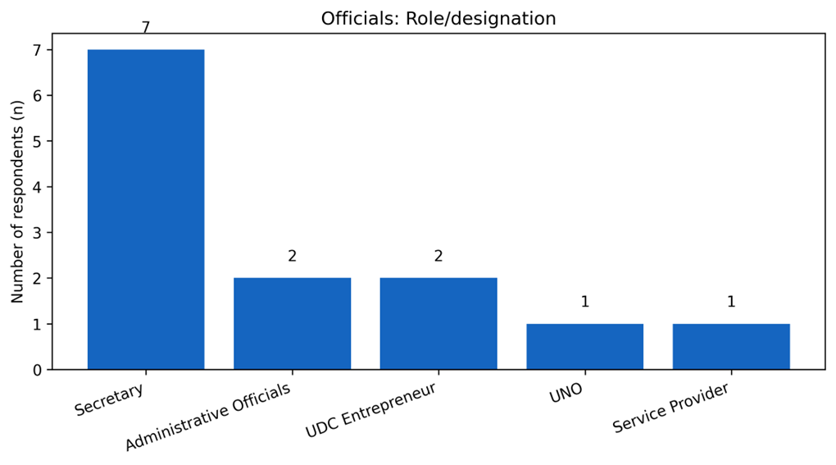

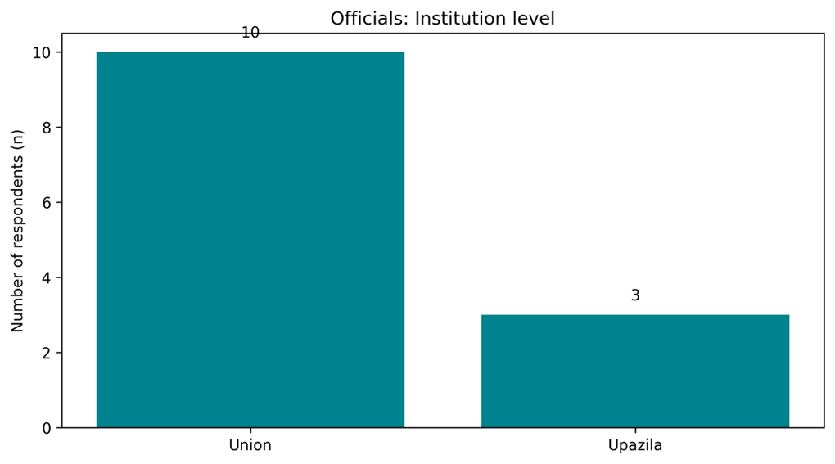
Figure 7. Officials: Institution level (n shown).
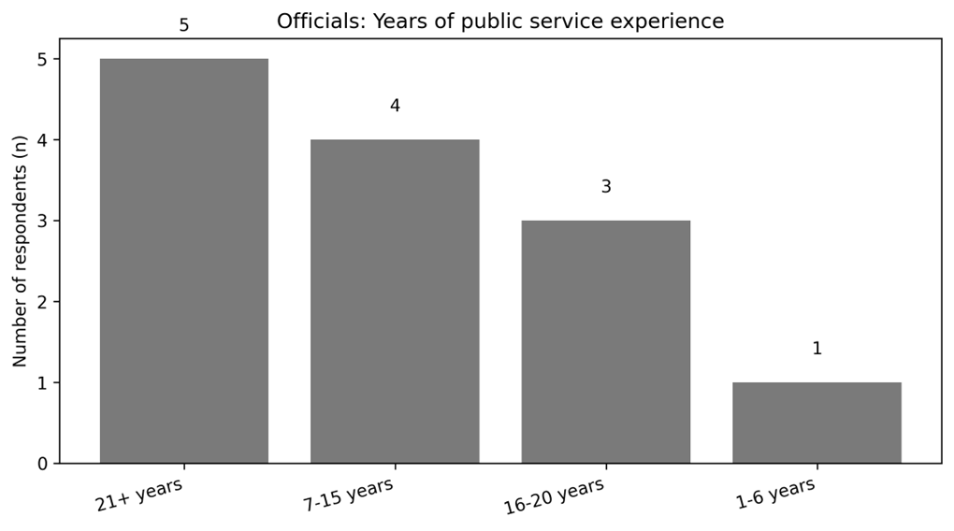
Figure 8. Officials: Years of experience

4.4 E-service Quality and System Performance
4.4.1 Citizens’ assessment of e-service quality
This subsection reports citizens’ perceptions of e-service quality as captured through five service-experience items covering accessibility/uptime, service findability, clarity of instructions/forms, transparency of document/fee information, and perceived data security. Responses were coded on a five-point scale (1 = strongly disagree to 5 = strongly agree). Table 4.3 presents item-level descriptive statistics, followed by the composite e-service quality index in Table 4.4.
Table 4.3: E-service Quality Items (Citizens, N = 102)
Dimension | Mean | SD | N
Accessibility/uptime | 3.43 | 0.75 | 102
Findability | 3.29 | 0.89 | 102
Clarity of instructions/forms | 3.56 | 0.78 | 102
Transparency of fees/docs | 3.59 | 0.85 | 102
Perceived data security | 3.31 | 0.89 | 102
Note: Higher mean values indicate more positive perceptions of the e-service experience.
Overall, citizens reported a moderately positive assessment of e-service quality. The strongest dimension was Transparency of fees/docs (M = 3.59, SD = 0.85), closely followed by Clarity of instructions/forms. By contrast, the weakest dimension was Findability (M = 3.29, SD = 0.89). Substantively, this pattern suggests that respondents were relatively more confident about the clarity and transparency of information provided on the portal, while they were less consistently positive about quickly locating services and, to a lesser extent, about data security.
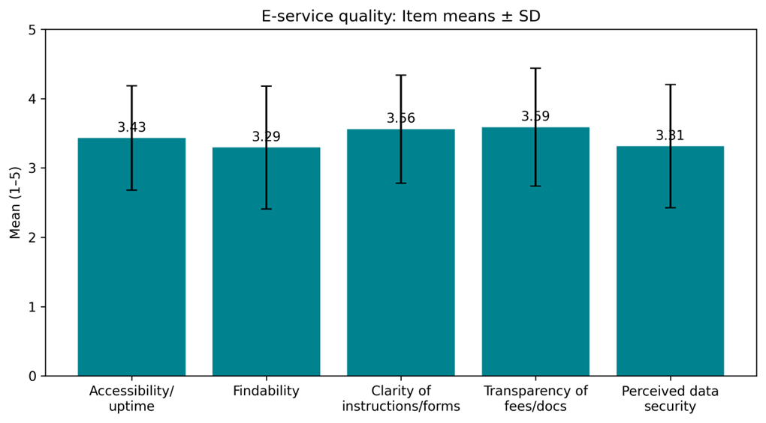
Figure 9. E-service quality items: Means ± SD.

Table 4.4: E-service Quality Index (Citizens)
Index | Mean | SD | N
E-service Quality Index (mean of 5 items) | 3.44 | 0.62 | 102
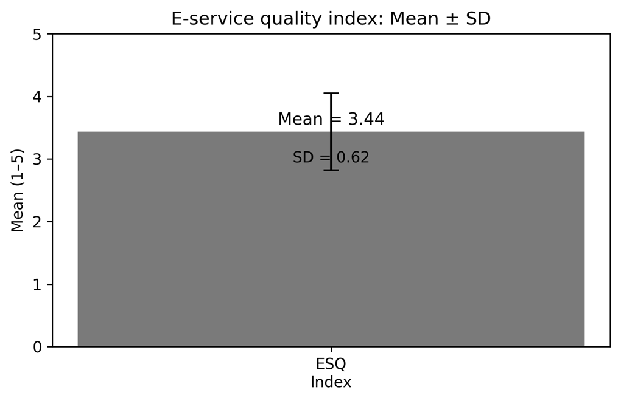
As shown in Table 4.4, the overall e-service quality index averaged 3.44 (SD = 0.62) on a 5-point scale, indicating that the typical respondent leaned slightly above the neutral midpoint in evaluating system performance. In the discussion chapter, this overall pattern is interpreted alongside administrative burden outcomes, because service quality and burden reduction are expected to move together in digital service settings.
Figure 10. E-service quality index:
Mean ± SD.

4.4.2 Officials’ assessment of system performance
To triangulate citizen perceptions, the officials’ survey captured provider-side assessments of system readiness and performance conditions. Given the smaller provider sample (N = 13), the results are presented descriptively, focusing on core operational enablers: availability of ICT equipment, reliability of internet connectivity, staff ICT competence, and perceived process simplification through reduced manual steps.

Table 4.5: Officials’ Assessment of System Performance (N = 13)
Indicator | Mean | SD | N
ICT equipment adequacy | 3.31 | 0.85 | 13
Internet reliability | 2.85 | 0.99 | 13
Staff ICT competence | 3.31 | 0.85 | 13
Process simplification (fewer manual steps) | 4.08 | 0.28 | 13
Note: Officials’ responses were coded to align with the five-point agreement scale where applicable. In two items, response categories were recorded as Agree/Neutral/Disagree; these were mapped to 4/3/2 respectively to retain scale interpretability.
A clear convergence emerges between the two datasets on the practical logic of e-services. Officials strongly endorsed the claim that e-services reduce manual steps (M = 4.08), which aligns with citizens’ generally positive ratings on clarity and transparency of the online process. At the same time, the provider-side profile points to operational constraints that plausibly explain why citizen ratings are not uniformly high across all quality dimensions. Internet reliability has the lowest official mean (M = 2.85), suggesting that service continuity and speed remain dependent on infrastructure stability. Officials’ assessments of ICT equipment adequacy (M = 3.31) and staff ICT competence (M = 3.31) were moderate, indicating functional capacity but with room for strengthening—particularly if the objective is to reduce citizens’ dependence on repeated support and to deliver a consistently smooth user experience.

4.5 Administrative Burden
This section examines administrative burden as experienced by citizens when using local government e-services in Hathazari Upazila. Consistent with the study’s framework, burden is reported through three dimensions—learning costs, compliance costs, and psychological costs. The citizen survey provides the primary evidence, while the officials’ survey is used to clarify why certain burden points persist in practice, particularly where implementation constraints (skills, verification rules, or system conditions) limit the burden-reducing potential of digital channels.
4.5.1 Learning Costs (Time/Effort to Understand the Process)
Learning costs capture the time and effort required to understand how to use the e-service platform and complete the process. On the composite learning-cost index (higher scores indicate higher burden), citizens reported a mean of 2.56 (SD = 0.63). Table 4.6 reports item-level indicators.
Table 4.6: Learning Cost Indicators (Citizens, N = 102)
Indicator | Mean | SD | N
Spent a lot of time learning how to use the e-service system (Q7) | 2.90 | 0.96 | 102
Online system requires less effort than visiting office (reverse-coded) (Q8R) | 1.85 | 0.81 | 102
Needed to call/visit office because website was unclear (Q9) | 2.92 | 0.98 | 102

From an operational standpoint, officials’ responses reinforce that learning-related challenges remain salient for a portion of service users—particularly regarding digital skills and the need for assistance. Table 4.7 summarizes provider-side perceptions of these learning barriers.
Figure 11. Learning cost indicators (citizens): Means ± SD.
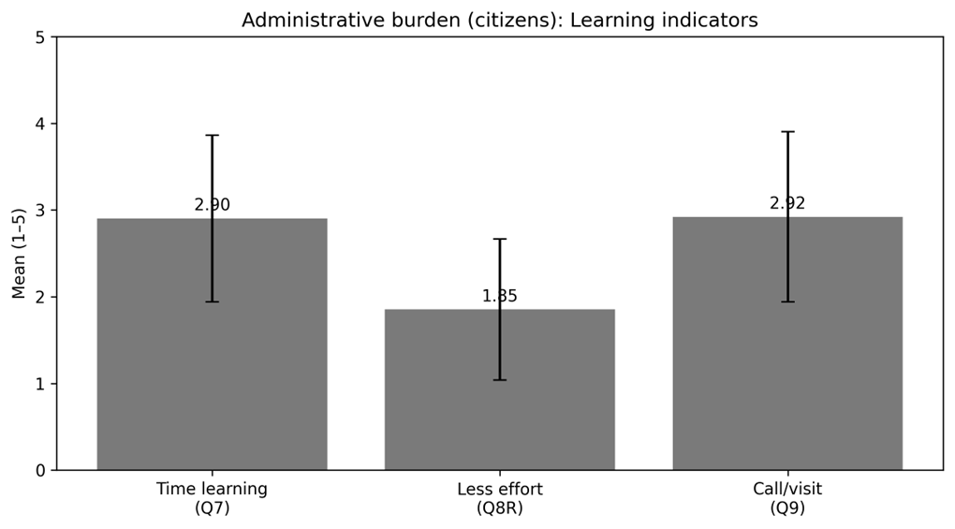
Table 4.7: Officials’ Perception of Learning Challenges (N = 13)
Indicator | Mean | SD | N
Citizens struggle to understand steps without assistance (Item 5) | 2.77 | 0.83 | 13
Citizens lack digital skills to use e-services independently (Item 6) | 3.69 | 0.48 | 13
Citizens require repeated explanation of requirements/procedures (Item 7) | 3.00 | 0.58 | 13
4.5.2 Compliance Costs (Time/Resources to Meet Requirements)
Compliance costs refer to the time, documentation, and resources required to meet procedural requirements, including waiting time and extra expenditures beyond official fees. Even in a digital process, citizens reported a mean compliance-cost index of 3.22 (SD = 0.63), suggesting that compliance burdens are still moderate to severe. Table 4.8 presents the item-level indicators.
Table 4.8: Compliance Cost Indicators (Citizens, N = 102)
Indicator | Mean | SD | N
Could upload/submit required documents without issues (reverse-coded) (Q12R) | 2.80 | 0.91 | 102
Spent a lot of time waiting (online or in-person) (Q13) | 3.30 | 0.89 | 102
Had extra costs beyond official fee (Q14) | 3.26 | 0.97 | 102
Had to submit many documents/requirements (Q15) | 3.49 | 0.91 | 102
Officials’ responses point to a key structural reason for persistent compliance burden: even when services are started online, completion often still involves multiple contacts or visits—typically related to verification, document checking, or follow-up requirements. Table 4.9 reports the provider-side indicator of this bottleneck.

Figure 12. Compliance cost indicators (citizens): Means ± SD.

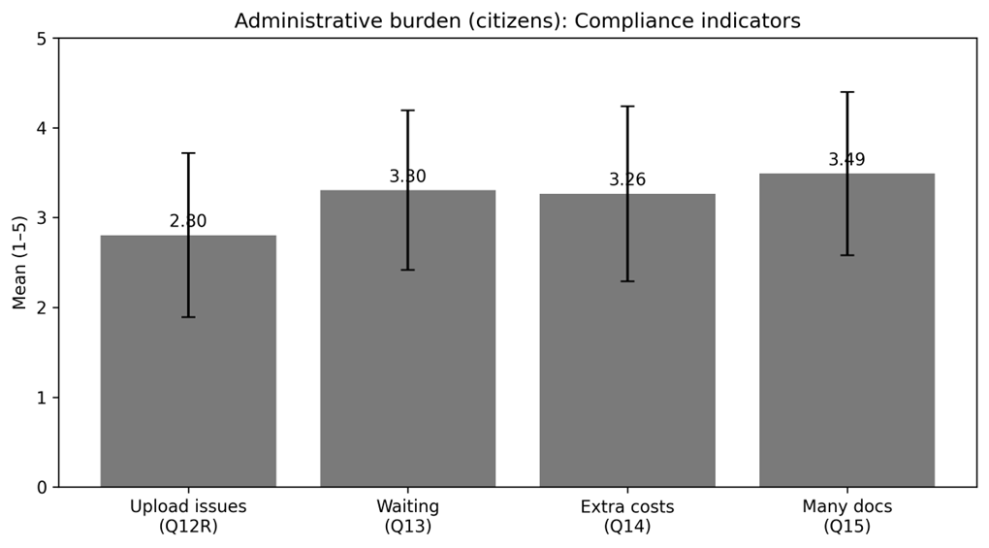
Table 4.9: Officials’ View of Compliance/Process Bottlenecks (N = 13)
Indicator | Mean | SD | N
Even with e-service, citizens still need multiple visits/contacts (Item 8) | 4.15 | 0.38 | 13

4.5.3 Psychological Costs (Stress/Frustration)
Psychological costs reflect anxiety, uncertainty, and frustration experienced during the e-service process, including fear of errors, system failure, or delays. Citizens reported the highest average burden in this dimension, with a psychological-cost index mean of 3.48 (SD = 0.78). Item-level statistics are presented in Table 4.10.
Table 4.10: Psychological Cost Indicators (Citizens, N = 102)
Indicator | Mean | SD | N
Anxious that application would fail due to system error (Q17) | 3.54 | 0.89 | 102
Anxiety/frustration while completing process (Q18) | 3.00 | 0.00 | 37
Feeling while waiting for outcome: frustrating → satisfying (coded as burden) (Q19) | nan | nan | 0

Officials’ responses provide additional context on psychological stress triggers, particularly the extent to which citizens become anxious about making mistakes and frustrated when systems are complex or slow. These indicators are summarized in Table 4.11.
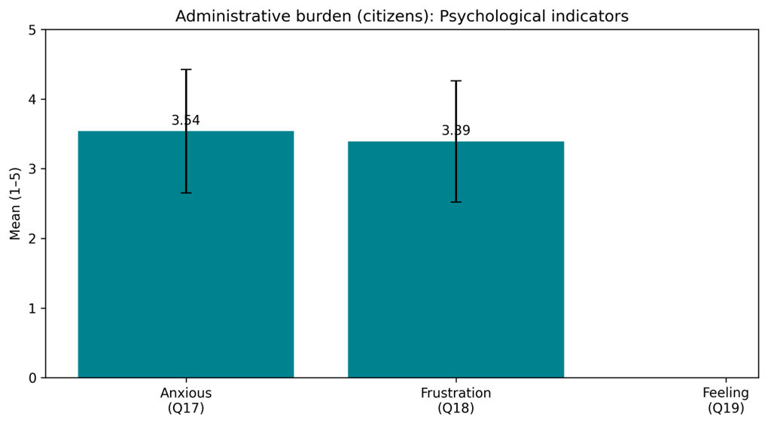
Figure 13. Psychological cost indicators (citizens): Means ± SD.

Table 4.11: Officials’ View of Psychological Stress Factors (N = 13)
Indicator | Mean | SD | N
Citizens feel stressed/anxious about making mistakes (Item 11) | 2.69 | 0.75 | 13
Citizens become frustrated when the system is complex or slow (Item 12) | 3.23 | 0.73 | 13

4.5.4 Summary of administrative burden results
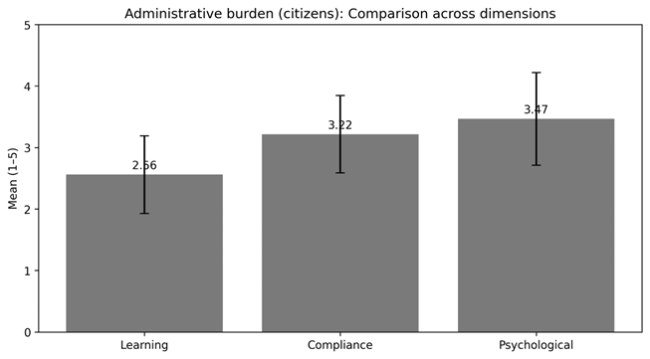
Hathazari Upazila is associated with diverse patterns of burden reduction across dimensions.Learning costs are quite modest (M = 2.56), indicating that many respondents can complete the fundamental procedures without requiring large time investment—though officials continue to detect significant gaps in citizens' digital abilities and the need for advice. Compliance costs remain substantially greater (M = 3.22), reflecting lengthy waiting time, documentation demands, and additional costs, which authorities confirm through high agreement that several contacts/visits may still be required.Psychological costs are highest (M = 3.48), indicating that uncertainty and frustration—especially around system errors, complexity, and delays—continue to shape the citizen experience even when services move online.
Ranking the burden dimensions by mean score (highest to lowest) yields: Psychological costs, Compliance costs, and Learning costs.
Figure 14. Burden dimensions (citizens): Means ± SD.

4.7 Administrative Efficiency and Overall Impact
This section brings together descriptive evidence on administrative efficiency (RQ2) with formal hypothesis testing (H1–H4). Efficiency results are presented in a comparative form using citizens’ experience-based indicators and officials’ operational assessments. The hypothesis tests then examine the central quantitative model of this thesis—whether e-service quality reduces administrative burden, whether burden is associated with citizen satisfaction, and whether burden functions as a pathway through which e-service quality influences satisfaction.
4.7.1 Administrative efficiency (RQ2)
Administrative efficiency is captured here as perceived time savings, process streamlining, and overall convenience. Citizens’ indicators reflect how users experience the speed and ease of the digital process, while officials’ indicators reflect whether office processes are being simplified in practice (for example, fewer manual steps, reduced service time, and improved overall efficiency). Table 4.15 provides a side-by-side summary.
Table 4.15: Administrative Efficiency Indicators (Citizens vs Officials)
Figure 15. Citizen satisfaction items: Means ± SD.

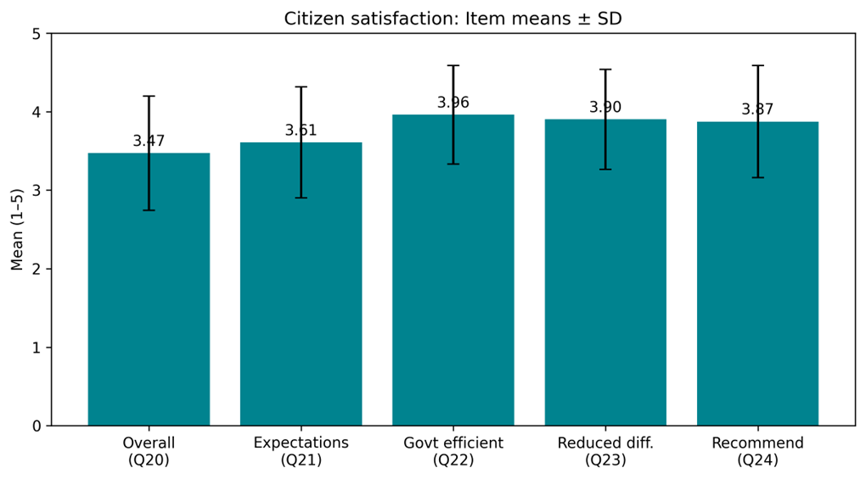
Efficiency aspect | Citizens indicator | Citizens Mean | Citizens SD | Citizens N | Officials indicator | Officials Mean | Officials SD | Officials N
Speed / time saving | Perceived efficiency gains from digitalization (Q22) | 3.96 | 0.63 | 102 | Citizen service requires less time than before (Item 9) | 4.31 | 0.48 | 13
Process streamlining | Reduced overall difficulties vs traditional service (Q23) | 3.90 | 0.64 | 102 | E-service reduces manual steps (Item 4) | 4.08 | 0.28 | 13
Convenience / usability → satisfaction | Fast & easy e-service increases satisfaction (Q25; rescaled) | 5.00 | 0.00 | 95 | Overall administrative efficiency has improved (Item 16) | 4.00 | 0.41 | 13
Note: Citizen indicators are drawn from items Q22, Q23, and Q25 (Q25 rescaled to align with a 5-point interpretation). Officials’ indicators are drawn from Items 4, 9, and 16. Higher values indicate stronger agreement with efficiency gains.

Two patterns stand out. First, citizens generally agreed that digitalization is improving government efficiency and reducing service difficulties, suggesting that the user-facing process is perceived as comparatively faster and more convenient than traditional channels. Second, officials reported strong agreement that manual steps have reduced and that overall administrative efficiency has improved, providing supply-side support for citizens’ efficiency perceptions.
Figure 16. Administrative efficiency indicators: Citizens vs Officials (Means ± SD).
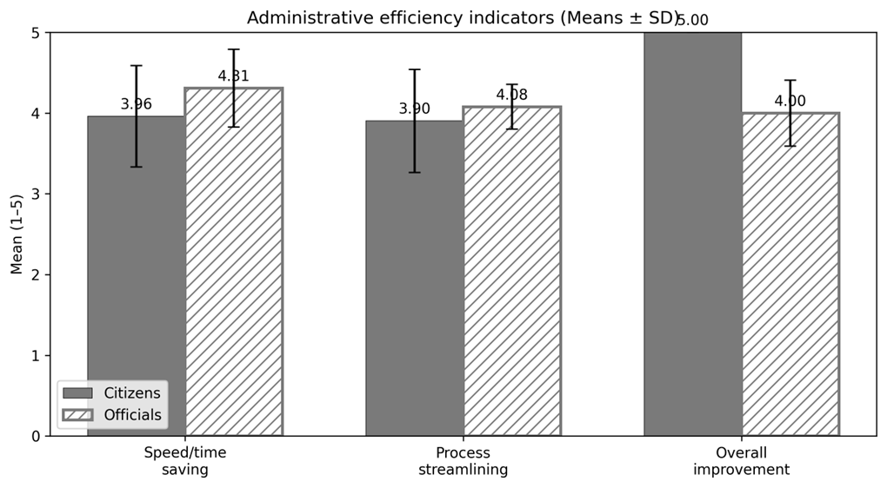

4.7.2 Hypothesis testing using regression models (H1–H3)
To test the core hypotheses, three bivariate regression models were estimated using citizen survey indices. Model A tests whether e-service quality predicts administrative burden (H1). Model B tests whether administrative burden predicts citizen satisfaction (H2). Model C tests whether e-service quality predicts citizen satisfaction (H3). Table 4.16 reports the regression summaries.
Table 4.16: Regression Results Summary (H1–H3)
Model | Dependent variable | Predictor | B | SE B | β | t | Sig. | R² | Adj. R² | F | df
Model A (H1) | Administrative burden | ESQ | -0.325 | 0.074 | -0.401 | -4.382 | < .001 | 0.161 | 0.153 | 19.203 | 1,100
Model B (H2) | Citizen satisfaction | Burden | -0.320 | 0.092 | -0.329 | -3.487 | < .001 | 0.108 | 0.100 | 12.162 | 1,100
Model C (H3) | Citizen satisfaction | ESQ | 0.491 | 0.061 | 0.625 | 7.998 | < .001 | 0.390 | 0.384 | 63.968 | 1,100
Note: B = unstandardized coefficient; β = standardized coefficient; Sig. = p-value. Analyses are based on available cases (N = 102).

Figure 17. Standardized regression effects (β and p shown).
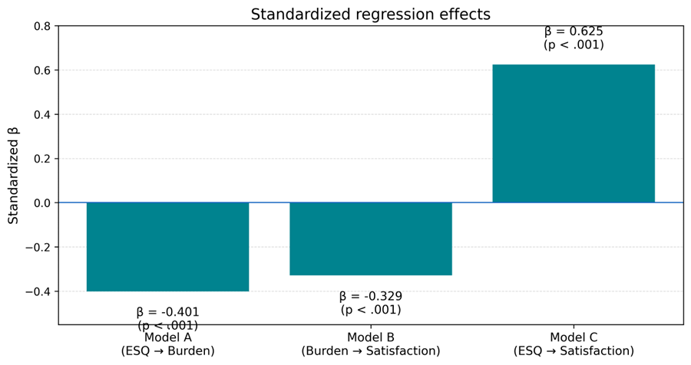

Figure 18: Model A (H1) — E-service Quality → Administrative Burden
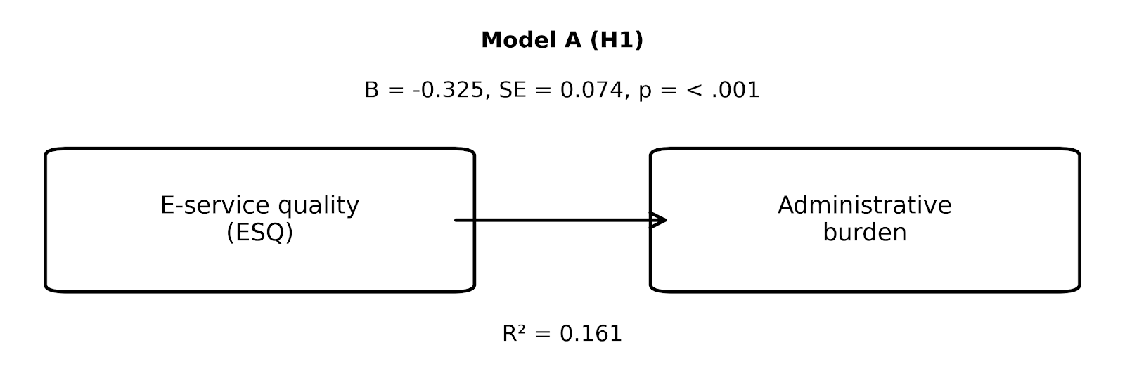
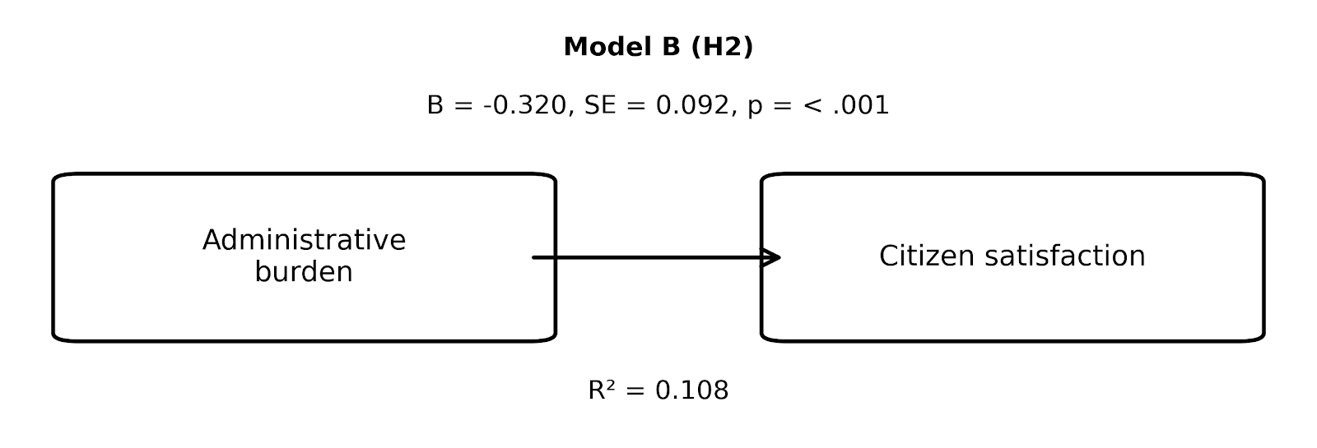
Figure 19: Model B (H2) — Administrative Burden → Citizen Satisfaction

Figure 20 : Model C (H3) — E-service Quality → Citizen Satisfaction
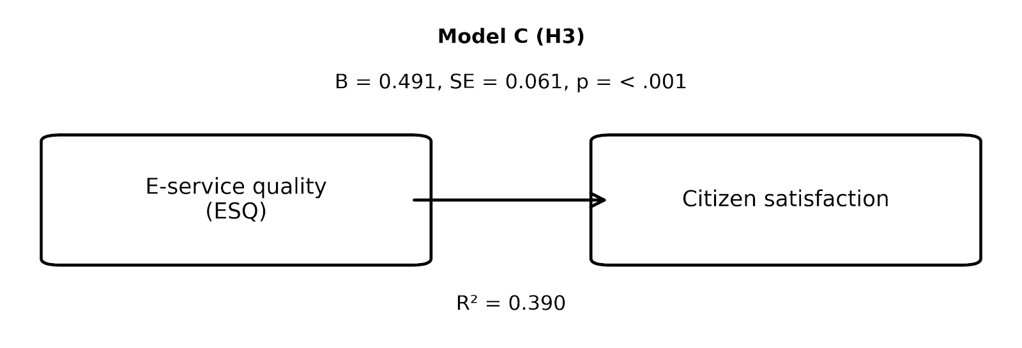4.7.3 Mediation / indirect effect (H4)
A mediation model (PROCESS Model 4 logic) was estimated to examine whether administrative burden mediates the relationship between e-service quality and citizen satisfaction (H4). The a-path captures the effect of e-service quality on burden; the b-path captures the effect of burden on satisfaction while controlling for e-service quality; the total effect (c) captures the overall effect of e-service quality on satisfaction; and the direct effect (c′) captures the remaining effect of e-service quality on satisfaction after accounting for burden. The indirect effect (a×b) was assessed using bootstrapping (5,000 resamples) to obtain a bias-free confidence interval.
Table 4.17A: Mediation Path Coefficients (Model 4)
Path | B | SE | t | Sig.
a (ESQ → Burden) | -0.325 | 0.074 | -4.382 | < .001
b (Burden → Satisfaction | ESQ) | -0.091 | 0.083 | -1.100 | .274
c (Total effect: ESQ → Satisfaction) | 0.491 | 0.061 | 7.998 | < .001
c′ (Direct effect: ESQ → Satisfaction | Burden) | 0.462 | 0.067 | 6.892 | < .001
Note: Paths are estimated using OLS regression with citizen indices. Sig. values follow conventional thresholds.
Figure 21. Indirect effect: bootstrap 95% CI.
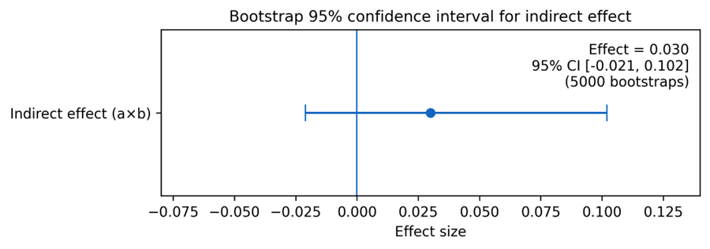

Table 22 B: Indirect Effect of ESQ on Satisfaction via Administrative Burden
Effect | B | BootLLCI (95%) | BootULCI (95%) | Bootstraps
Indirect effect (a×b) | 0.030 | -0.021 | 0.102 | 5000
Note: If the 95% bootstrap confidence interval does not include zero, the indirect effect is statistically supported.

Figure 23: Mediation model (H4) — E-service Quality → Administrative Burden → Citizen Satisfaction
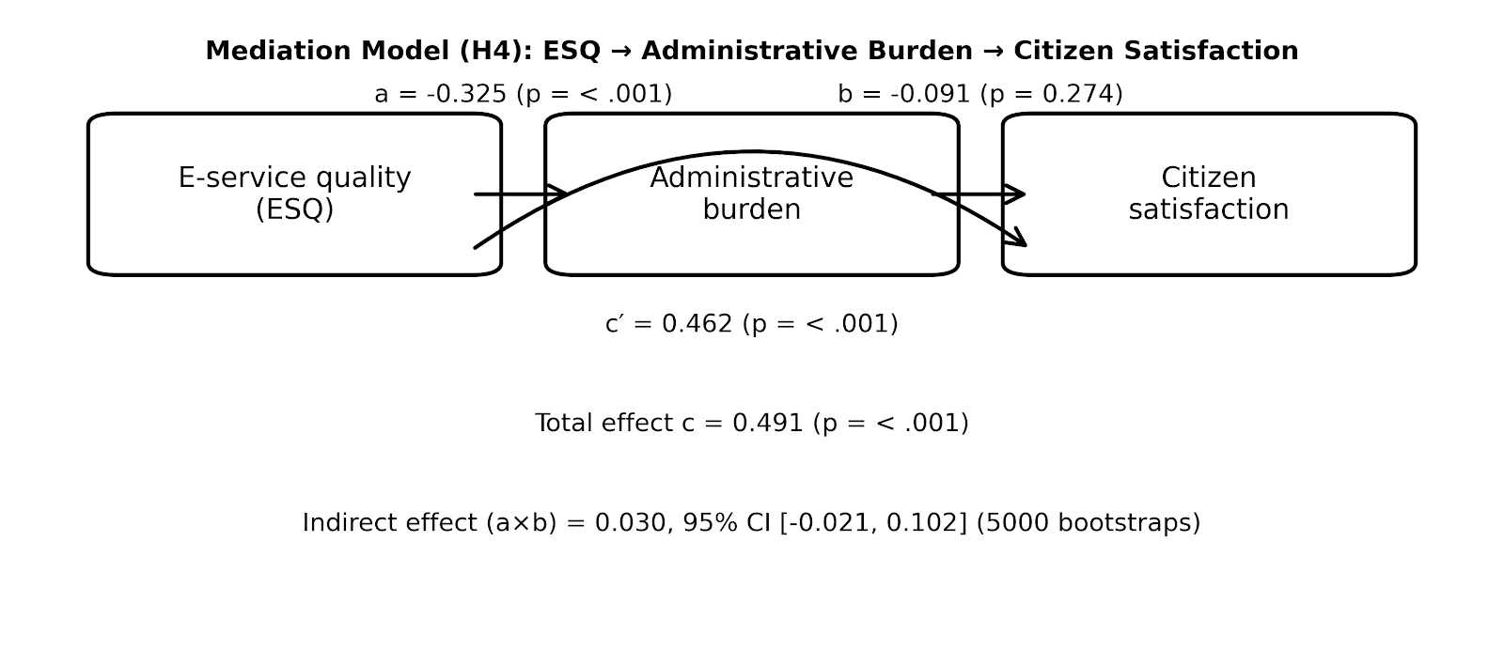
4.7.4 Integrated quantitative conclusion
Taken together, the quantitative results provide a coherent answer to the study’s research questions. First, citizens’ descriptive results indicate that administrative burden is not eliminated by digitalization, but varies across learning, compliance, and psychological costs (RQ1). Second, both citizens and officials report meaningful efficiency gains in speed and process streamlining, supporting the claim that e-services are improving administrative efficiency in Hathazari Upazila (RQ2). Third, the regression evidence shows that higher administrative burden is associated with lower citizen satisfaction (RQ3). Finally, the model results indicate that e-service quality exerts a strong positive total effect on satisfaction, while also reducing burden; however, the indirect pathway through burden is comparatively modest in magnitude and, based on the bootstrap confidence interval, does not reach a conventional level of statistical support in this sample (RQ4).
With respect to hypothesis testing, H1 was supported (ESQ significantly reduced administrative burden). H2 was supported (higher burden significantly reduced satisfaction; equivalently, reduced burden improved satisfaction). H3 was supported (ESQ significantly increased satisfaction). H4 was not supported based on the bootstrap confidence interval for the indirect effect.

CHAPTER FIVE
QUALITATIVE ANALYSIS
5.1 Introduction
This chapter explains the lived experiences behind the survey patterns reported in Chapter 4. While the quantitative models indicate how e-service quality, administrative burden, and citizen satisfaction relate statistically, the open-ended responses clarify why those relationships take the form observed in Hathazari Upazila. Accordingly, the qualitative analysis is used here as an interpretive layer—highlighting concrete difficulties, coping strategies, and practical implementation realities that sit beneath the numerical averages.
Two sources of qualitative evidence are used. First, citizens (N = 102) provided open-ended comments on meanings of “easy access to government,” difficulties experienced during e-service use, the most confusing parts of the online process, time and effort demands, the need for any physical office visits, bad experiences (technical versus administrative causes), and suggestions for improvement. Second, officials (N = 13) provided open-ended reflections on the operational state of e-service delivery (equipment, connectivity, and human resources), the most common learning and compliance barriers observed among citizens, stress triggers, perceived citizen impacts, efficiency implications, and needed system changes.
The analysis follows a thematic approach. Responses were first read repeatedly and coded at the phrase and sentence level. Coding combined a deductive lens—anchored in administrative burden theory (learning, compliance, and psychological costs)—with inductive openness to themes that emerged directly from respondents’ wording (such as network instability, office–online hybridity, or perceptions of fairness). Codes were then clustered into categories and consolidated into higher-order themes used to structure Sections 5.4–5.7.
5.2 Introduce with Respondents
5.2.1 Citizen respondents (qualitative subset)
Open-ended comments were provided by a substantial portion of the citizen sample across the qualitative items. Because the study’s purpose is interpretive rather than statistical in this chapter, the emphasis is placed on the content of accounts rather than detailed demographic breakdowns. All responses were anonymized. Quotes are attributed using an identifier and two non-identifying descriptors (gender and age group), for example: (Citizen R12, Female, 26–35).
5.2.2 Officials respondents (qualitative subset)
Officials’ open-ended responses reflect diverse institutional positions involved in e-service delivery—frontline service providers, administrative staff, and roles with ICT or coordination functions. To preserve confidentiality, quotations are anonymized using a simple label format that includes role category and years of public service experience, for example: (Official O3, Service Provider, 7–15 years).

5.3 Thematic Analysis
5.3.1 Coding strategy
Coding proceeded in two stages. In the first cycle, descriptive codes were applied to capture explicit content (e.g., “server down,” “needs guidance,” “document verification,” “office visit,” “unclear instructions”). In the second cycle, codes were interpreted and grouped into conceptual clusters aligned with the study’s conceptual framework. This approach retained the explanatory strength of administrative burden theory while avoiding forcing all statements into pre-defined boxes—allowing recurrent operational themes to remain visible.
5.3.2 Theme mapping to research questions
Themes are mapped to the research questions as follows. Themes related to learning, compliance, and psychological costs speak directly to RQ1 (the extent and character of burden reduction). Themes describing speed, process streamlining, and online–offline hybridity address RQ2 (administrative efficiency). Themes connecting hassle, stress, and perceived convenience inform RQ3 (burden–satisfaction relationship). Finally, themes explaining mechanisms—how reduced steps, reduced uncertainty, or reduced dependence on intermediaries translate into trust and satisfaction—are used to interpret RQ4.
5.4 E-service Quality and System Performance
This section synthesizes citizen and official narratives around e-service quality and system performance. Across both groups, four interlinked theme blocks emerged: (i) ease and convenience, (ii) system reliability and glitches, (iii) transparency and reduced broker influence, and (iv) backend constraints. Together, these themes help explain why citizens rated e-service quality positively overall in Chapter 4, while still reporting uneven experiences across items and circumstances.
Theme: Ease and convenience
Many citizens describe e-services as valuable primarily because they reduce the felt distance to government—saving time, reducing travel, and enabling quicker access to information or submission. These accounts are consistent with the comparatively strong quantitative ratings on clarity and transparency and with officials’ emphasis on reduced manual steps and time savings.
Selected citizen quotes:
“"Easy Access to Government" refers to citizens' rapid, direct, and hassle-free participation in government services, information, and policy-making processes through the use of technology and policies. (Citizen R1, Male, 18–25)
“Getting official government facilities within a short period of time” (Citizen R3, Female, 18–25)
“Fast service :Government Services within a short period of time” (Citizen R6, Male, 18–25)
“Fast service :Government Services within a short period of time, Govt Service received via Internet, 24/7 Availability, Affordable” (Citizen R8, Male, 18–25)
Selected official quotes:
“Yes, administrative efficiency increases compared to traditional manual paper based service delivery system” (Official O1, UNO, 7-15 years)
“it reduce time of Service Delivery” (Official O5, Secretary, 21+ years)
Interpretive link to Chapter 4: These narratives reinforce the quantitative pattern of generally positive e-service quality ratings, while clarifying why variability remains—particularly where system reliability and required offline steps constrain the promised convenience of digital delivery.
Theme: System reliability and glitches
A recurring qualification in citizens’ accounts is that convenience depends on system reliability. When connectivity is weak or platform responsiveness declines, the digital channel can quickly shift from being ‘time-saving’ to being ‘time-consuming,’ often generating repeated attempts and uncertainty. Officials’ narratives echo this dependence on stable infrastructure, particularly internet reliability and adequate equipment.
Selected citizen quotes:
“Servers remain down sometimes” (Citizen R3, Female, 18–25)
“Network problem, website down” (Citizen R10, Female, 18–25)
“Server down” (Citizen R19, Female, 36–45)
“Server Down” (Citizen R21, Male, 26–35)
Selected official quotes:
“Lack internet connectivity, and specialized software” (Official O3, Udc entrepreneur, 7-15 years)
“Lacking proper internet connections, my experience is better than manual service delivery. It reduces many steps. Skill service provider required because citizens words while one service provider providing service . Others have to wait.” (Official O4, Service Provider, 7-15 years)
Interpretive link to Chapter 4: These narratives reinforce the quantitative pattern of generally positive e-service quality ratings, while clarifying why variability remains—particularly where system reliability and required offline steps constrain the promised convenience of digital delivery.
Theme: Transparency and reduced broker influence
A smaller but meaningful set of responses frame e-service quality in moral terms—associating online procedures with clearer rules and reduced need to rely on intermediaries. Where citizens perceive that fees and requirements are clearer online, the service is interpreted as more transparent and fair, with fewer opportunities for broker-driven manipulation. Officials similarly point to improved public trust and reduced complaints where processes become more standardized.
Selected citizen quotes:
“policy/process itself was complicated (administrative), Mostly for administrative reasons, but sometimes there were technical issues too.” (Citizen R101, Male, 18–25)
“website was poorly designed (technical),, policy/process itself was complicated (administrative)” (Citizen R9, Male, 18–25)
Selected official quotes:
“Positive, confusion reduced in terms of self service and instruction” (Official O8, Secretary, 16-20 years)
“Increases a lot” (Official O4, Service Provider, 7-15 years)
Interpretive link to Chapter 4: These narratives reinforce the quantitative pattern of generally positive e-service quality ratings, while clarifying why variability remains—particularly where system reliability and required offline steps constrain the promised convenience of digital delivery.
Theme: Backend constraints
Citizens’ comments also reveal the persistence of ‘hybrid’ service delivery. Even after initiating services online, many respondents still describe the need for office visits for verification, document checks, or completion steps. Officials’ responses help explain this persistence by pointing to staffing, training needs, equipment constraints, and rule-bound verification requirements—factors that keep some steps anchored in the physical office.
Selected citizen quotes:
“Yes,for certain reasons. Collection of my final document” (Citizen R21, Male, 26–35)
“Yes,for document Collection” (Citizen R28, Male, 36–45)
“Yes,for biometric” (Citizen R56, Female, 36–45)
“Yes,because I thought it would be easier to get the service from Union office” (Citizen R58, Male, 46–60)
Selected official quotes:
“Training of officials and and if I want to say something or recommend something to citizens that is to lower their expectations, I'm not saying that to compare to traditionals service delivery. But not keep the expectation so high” (Official O2, Administrative Officials, 21+ years)
“training” (Official O6, Administrative Officials, 16-20 years)
Interpretive link to Chapter 4: These narratives reinforce the quantitative pattern of generally positive e-service quality ratings, while clarifying why variability remains—particularly where system reliability and required offline steps constrain the promised convenience of digital delivery.

5.5 Administrative Burden
The open-ended narratives help clarify why administrative burden persists even when the service channel becomes digital. Citizens’ comments provide first-hand evidence of the points at which learning, compliance, and psychological costs are generated; officials’ accounts explain how these costs are reproduced by capacity limits, verification rules, and infrastructure constraints. The themes below are presented as an interpretive companion to the burden indices reported in Chapter 4.
5.5.1 Learning costs
Two learning-related patterns recur strongly: (i) respondents who experienced clear instructions and a familiar interface report that the process is straightforward, but (ii) many others describe digital literacy barriers—especially around understanding steps, language, form fields, and login/OTP procedures. Where these barriers are present, citizens often rely on informal assistance from family members, cyber cafés, or ‘someone who knows how to do it,’ which effectively shifts learning costs onto social networks and paid intermediaries.
Illustrative citizen accounts (instructions vs digital literacy barriers):
“Deciphering legal jargon in Terms of Service (ToS) and Privacy Policies. Understanding data sharing: Not knowing exactly what data is being collected or with whom it is being shared.” (Citizen R71, Male, 18–25)
“Online itself is an easy process. But the difficulty is when I need to go to the office with the online copies” (Citizen R3, Female, 18–25)
“Sometimes the server doesn't work properly and there is no smart way to find information.” (Citizen R12, Female, 26–35)
“Since I haven't used it, I don't have a good answer for this.” (Citizen R20, Male, 26–35)
Citizen accounts indicating informal help dependence (family/cyber café/agents):
“1. Servers were slow and sometimes unaccessible under gravy traffic. 2. The UIs were sometimes not very user friendly” (Citizen R101, Male, 18–25)
“server breakdown,frequently need to fillup the information whenever it needs to reconnect .” (Citizen R86, Female, 26–35)
“"Network slowness and insufficient information to reach the site” (Citizen R52, Female, 18–25)
Officials largely confirm this pattern. They commonly describe citizen difficulty with understanding steps and repeatedly needing explanation, and several explicitly argue for structured support mechanisms—guidance desks, more user-friendly forms, and practical training or orientation.
Selected official reflections (why learning burdens persist):
“They lack digital skills, mainly understanding. The language and instruction” (Official O1, UNO, 7-15 years)
“understanding steps” (Official O2, Administrative Officials, 21+ years)
Officials’ suggested improvements (guidance, training, simplified forms):
“Training of officials and and if I want to say something or recommend something to citizens that is to lower their expectations, I'm not saying that to compare to traditionals service delivery. But not keep the expectation so high” (Official O2, Administrative Officials, 21+ years)
“What can be changed is limited by the law. So if I want to change. I can't due the law bined me” (Official O1, UNO, 7-15 years)
5.5.2 Compliance costs
Citizens’ open-ended responses indicate that compliance costs are reduced in some respects—especially where travel and repeated physical presence decline—but are not eliminated. A common experience is the continuation of ‘verification visits’ even after online initiation. Respondents also describe document complexity (collecting, scanning, uploading, and correcting paperwork), and delays driven by waiting, repeated submissions, or incomplete processing.
Citizen accounts of reduced travel but persistent verification visits:
“Yes, for hardcopy” (Citizen R44, Female, 36–45)
“Yes,for biometric” (Citizen R56, Female, 36–45)
“Yes,because I thought it would be easier to get the service from Union office” (Citizen R58, Male, 46–60)
“Yes, but because physical presence was absolutely essential.” (Citizen R70, Male, 18–25)
Citizen accounts highlighting document complexity and procedural requirements:
“1. Servers were slow and sometimes unaccessible under gravy traffic. 2. The UIs were sometimes not very user friendly” (Citizen R101, Male, 18–25)
“server breakdown frequently needs to fill up the information whenever it needs to reconnect .” (Citizen R86, Female, 26–35)
“Slow network and insufficient information to browse through the site” (Citizen R52, Female, 18–25)
Citizen accounts describing waiting time or repeated submission attempts:
“Regular. Not much delay” (Citizen R9, Male, 18–25)
“An hour and a half. Depends on the type of work. This is how long it took to process my driving license.” (Citizen R70, Male, 18–25)
“Online service takes less time, but going to the office to get service takes a long time.” (Citizen R90, Female, 18–25)
Officials’ accounts provide the institutional logic behind these compliance burdens. They point to rule-bound checks, document verification requirements, and coordination frictions across offices or units—factors that keep parts of the process ‘sticky’ and difficult to fully digitize.
Selected official reflections (policy rules, checks, coordination bottlenecks):
“visits it remains the same but considerably a little less” (Official O1, UNO, 7-15 years)
“Visit remains the same as and procedure became easier” (Official O3, Udc entrepreneur, 7-15 years)
5.5.3 Psychological costs
Psychological costs appear in two contrasting forms. For some citizens, digital processes create relief—particularly where they perceive fewer opportunities for harassment or arbitrary demands. For others, anxiety emerges from uncertainty: fear of making mistakes, concern that an error will ‘block’ the process, and frustration when systems are slow or unresponsive. This anxiety is amplified in moments of downtime or network instability, when citizens cannot easily predict what will happen next or how long the delay will last.
Citizen accounts of anxiety and frustration due to errors, delays, or system problems:
“policy/process itself was complicated (administrative), mostly for administrative reasons, but sometimes there were technical issues too.” (Citizen R101, Male, 18–25)
“website was poorly designed (technical),, policy/process itself was complicated (administrative)” (Citizen R9, Male, 18–25)
Citizen accounts reflecting relief linked to fairness/transparency (where present):
“policy/process itself was complicated (administrative), Mostly for administrative reasons, but sometimes there were technical issues too.” (Citizen R101, Male, 18–25)
“website was poorly designed (technical),, policy/process itself was complicated (administrative)” (Citizen R9, Male, 18–25)
Officials similarly observe that frustration peaks when the system is slow, the network is down, or users become uncertain about whether a submission has been accepted. In this sense, the psychological cost is not only an individual feeling, but also a predictable consequence of infrastructure fragility and unclear feedback mechanisms in the service process.
Selected official reflections (stress triggers: slow systems, network downtime):
“It increases stress as the service is available 24/7. So on the other hand, citizen have access over it all the time there stress reduced” (Official O1, UNO, 7-15 years)
“After everything become online is reduced stress in many ways” (Official O2, Administrative Officials, 21+ years)
Synthesis link to Chapter 4: The qualitative evidence aligns closely with the quantitative burden profile. Learning burdens were comparatively lower on average (M = 2.56, SD = 0.63), but persist where digital literacy is uneven and support is informal. Compliance burdens remain moderate (M = 3.22, SD = 0.63) because verification visits and document-heavy requirements continue. Psychological burdens were the highest of the three (M = 3.48, SD = 0.78), and respondents’ narratives locate this stress precisely in uncertainty, errors, and system downtime. Overall burden remains present (M = 3.08, SD = 0.50), reinforcing the conclusion that e-services reduce—but do not remove—administrative hassle.

5.6 Citizen Satisfaction
Citizens’ satisfaction narratives are strongly grounded in practical benefits rather than abstract approval. Across responses, satisfaction is repeatedly framed as (i) time saved, (ii) less hassle, and (iii) perceptions of fairness or transparency—especially where rules and fees are clearer and dependence on intermediaries is reduced. Officials reinforce these points by describing reduced complaints, improved acceptance of digital channels, and the belief that citizens value faster service and simpler steps most.
Theme: “Time saved” satisfaction
“Online did not take much time. But offline took 3-5 working days” (Citizen R3, Female, 18–25)
“not much time” (Citizen R12, Female, 26–35)
“it took considerable time” (Citizen R25, Female, 18–25)
Official triangulation (observed impacts on citizens):
“Positive, confusion reduced in terms of self service and instruction” (Official O8, Secretary, 16-20 years)
“Increases a lot” (Official O4, Service Provider, 7-15 years)
Theme: “Less hassle” satisfaction
“1. Servers were slow and sometimes unaccessible under gravy traffic. 2. The UIs were sometimes not very user friendly” (Citizen R101, Male, 18–25)
“server breakdown,frequently need to fillup the information whenever it needs to reconnect .” (Citizen R86, Female, 26–35)
Theme: “Fairness/transparency” satisfaction
“policy/process itself was complicated (administrative), mostly for administrative reasons, but sometimes there were technical issues too.” (Citizen R101, Male, 18–25)
“website was poorly designed (technical),, policy/process itself was complicated (administrative)” (Citizen R9, Male, 18–25)
Tie to RQ3 and RQ4: These themes clarify why administrative burden and satisfaction move together. When citizens describe satisfaction, they are often describing the absence of administrative burden: fewer steps, fewer trips, less uncertainty, and fewer opportunities for arbitrary demands. In other words, reduced burden functions as a mechanism that converts e-service quality into satisfaction—especially through saved time and reduced procedural stress.

5.7 Administrative Efficiency and Overall Impact
The qualitative evidence converges on a balanced conclusion: e-service delivery has improved administrative efficiency and citizen experience, but it operates within institutional constraints that prevent full burden elimination. Respondents repeatedly describe faster processing and fewer steps when the system works well, alongside bottlenecks created by internet instability, limited equipment, staff capacity, and verification rules.
Theme: Faster processing and fewer steps
Citizens’ one-word summaries often capture speed/convenience (and, at times, the opposite when the system fails):
“My experience was good because most of the time I use government services and the officials are very active in providing digital services.” (Citizen R3, Female, 18–25)
“Slow” (Citizen R5, Male, 26–35)
“Helpful and easy to use.” (Citizen R11, Female, 26–35)
“Helpful and easy to use” (Citizen R13, Male, 18–25)
Officials’ reflections on efficiency and workload/process change:
“Yes, administrative efficiency increases compared to traditional manual paper based service delivery system” (Official O1, UNO, 7-15 years)
“it reduce time of Service Delivery” (Official O5, Secretary, 21+ years)
Theme: Better coordination (or lack of it)
Several accounts point to coordination gaps—where progress depends on multiple checks, approvals, or unit-to-unit verification that may not be fully integrated digitally. In such cases, the citizen experiences the e-service as ‘started online but completed offline,’ which partially reduces burden but also introduces new uncertainty about responsibilities and timelines.
Theme: Institutional constraints (staffing, infrastructure, internet)
Officials’ descriptions of system performance constraints:
“Lack of skill personnel” (Official O2, Administrative Officials, 21+ years)
“Lack internet connectivity, and specialized software” (Official O3, Udc entrepreneur, 7-15 years)
Officials’ recommended changes (infrastructure, staffing, training, system upgrades):
“Training of officials and and if I want to say something or recommend something to citizens that is to lower their expectations, I'm not saying that to compare to traditionals service delivery. But not keep the expectation so high” (Official O2, Administrative Officials, 21+ years)
“Well established and dedicated, properly designed software in my union office” (Official O7, Secretary, 16-20 years)
Citizens’ improvement suggestions (what they want fixed first):
“Network available” (Citizen R8, Male, 18–25)
“Improve Server Stability and easy to navigate page, Digital Campaign for e-service” (Citizen R10, Female, 18–25)
“Improve server stability and easy to navigate” (Citizen R12, Female, 26–35)
Qualitative wrap-up: what these results add beyond the numbers
First, the qualitative evidence shows that ‘ease’ is conditional: the same digital service can feel efficient for digitally confident users and burdensome for others. Second, it reveals that administrative burden often shifts form rather than disappearing—moving from travel and queuing to documentation management, login/OTP problems, and uncertainty about submission status. Third, it identifies system reliability as a central hinge variable: network downtime and platform glitches convert convenience into frustration very quickly.
Fourth, it demonstrates why satisfaction may remain comparatively elevated despite ongoing burdens—because citizens place significant emphasis on time savings and diminished inconvenience in their overall judgement. Fifth, officials attribute the ongoing verification processes and coordination delays to adherence to regulations and limitations in capability, rather than solely to 'user mistake.’ Finally , triangulation reveals the entire impact: e-service delivery significantly enhances access and efficiency in Hathazari Upazila;nevertheless, more advancements rely on infrastructure stability, user support, and process redesigning rather than solely on digitalization.

CHAPTER SIX
DISCUSSION AND CONCLUSION
6.1 Introduction
This chapter discusses what the findings mean for local digital service delivery in Hathazari Upazila. It does not restate results; rather, it interprets the patterns, links them back to the study objectives, and answers the research questions in a way that can stand as the final thesis claim. The discussion intentionally integrates two sources of evidence: citizens’ responses (n = 102), which provide the primary test of relationships among e-service quality, administrative burden, efficiency and satisfaction; and officials’ responses (n = 13), which provide the implementation-side explanation for why particular burdens persist and why improvements are uneven across users.
The chapter proceeds in four steps. Section 6.2 tests hypotheses H1–H4 by combining the quantitative results with qualitative triangulation. Section 6.3 synthesizes the findings against the two specific objectives. Section 6.4 highlights the conceptual/analytical implications for administrative burden and digital government research. Section 6.5 concludes by presenting clear, direct answers to the four research questions.

6.2 Test of Research Hypothesis (H1–H4)
Hypothesis testing is presented as an integrated judgement rather than a purely statistical checklist. Accordingly, Table 6.1 reports the quantitative outcomes from Chapter 4, and then indicates how the qualitative evidence from Chapter 5 supports, clarifies, or qualifies each relationship in the Hathazari service context.
Table 6.1: Hypothesis Testing Summary
Hypothesis | Relationship tested | Quantitative evidence (Chapter 4) | Qualitative triangulation (Chapter 5) | Decision
H1 | ESQ → Burden (negative) | B = -0.325, SE = 0.074, p = 2.9e-05, R² = 0.161 | Citizens describe smoother completion when the system is clear/available; officials emphasize uneven digital literacy and the need for structured guidance. | Supported
H2 | Reduced burden → Satisfaction (positive) | B = -0.320, SE = 0.092, p = 0.000726, R² = 0.108 | Satisfaction is framed as time saved/less hassle; burden persists via verification visits, document complexity, and stress during downtime. | Supported
H3 | ESQ → Satisfaction (positive) | B = 0.491, SE = 0.061, p = 2.3e-12, R² = 0.390 | Citizens value clarity/reliability; officials report greater acceptance and fewer complaints where systems are stable. | Supported
H4 | ESQ → Burden → Satisfaction (mediation) | a×b = 0.030, 95% CI [-0.021, 0.102] (5000 bootstraps); b-path p = 0.274 | Narratives indicate a burden-reduction mechanism, but implementation constraints make the pathway uneven across users. | Not supported (CI crosses zero)

Hypothesis 1: Effect of E-Service Delivery on Administrative Burden
Null Hypothesis (H01): E-service delivery has no significant effect on administrative burden.
Alternative Hypothesis (H1): E-service delivery has a significant negative effect on administrative burden.
The statistical result supports H1: e-service quality is associated with lower administrative burden (B = -0.325, p = 2.9e-05; R² = 0.161). In practical terms, the better the platform performs—particularly in availability, clarity of instructions, and ease of locating services—the less ‘work’ citizens report having to do to complete the process.
The qualitative material explains why this relationship holds. Citizens describe the digital service as genuinely convenient when the system is stable and guidance is clear; however, they also report that burden returns quickly when steps are unclear, when they are unsure about requirements, or when technical interruptions occur. Officials confirm this unevenness by describing recurring citizen difficulty with understanding steps and the repeated need for support, implying that service quality improvements must include user-facing guidance and not only technical upgrades.

Hypothesis 2: Effect of Reduced Administrative Burden on Citizen Satisfaction
Null Hypothesis (H02):Reduced administrative burden has no significant effect on citizen satisfaction.
Alternative Hypothesis (H2):Reduced administrative burden has a significant positive effect on citizen satisfaction.
H2 is also supported statistically (B = -0.320, p = 0.000726; R² = 0.108). Given the burden index direction used in this thesis, the implication is straightforward: satisfaction improves as learning, compliance, and psychological costs decline.
Qualitative evidence makes the burden–satisfaction link almost intuitive. Citizens most often describe satisfaction through concrete reductions in hassle—time saved, fewer trips, and greater predictability. In contrast, when compliance requirements remain document-heavy or verification visits are still required, citizens report dissatisfaction and tiredness, which directly impact happiness. Official sources agree with this interpretation, particularly about how delays, slow systems, and network issues cause citizen frustration and complaints.

Hypothesis 3: Effect of E-Service Delivery on Citizen Satisfaction
Null Hypothesis (H03):E-service delivery has no significant effect on citizen satisfaction.
Alternative Hypothesis (H3): E-service delivery has a significant positive effect on citizen satisfaction.
H3 is strongly supported (B = 0.491, p = 2.3e-12; R² = 0.390). This indicates that citizens evaluate digital government not only by whether they obtain the service, but also by how the service feels to use—clarity, reliability, accessibility, and perceived security.
The qualitative findings clarify the content of ‘quality’ in this setting. Citizens interpret good performance as faster completion and reduced hassle, but they also interpret it as fairness and transparency—especially where steps and fees are clear and there is less perceived dependence on intermediaries. Officials add a supply-side mirror: where systems are stable and staff capacity is adequate, they perceive improved acceptance and reduced complaint pressure. Where equipment and internet are weak, the credibility of the service deteriorates quickly from the citizen’s viewpoint.

Hypothesis 4: Mediation Effect of Administrative Burden
Null Hypothesis (H04):Reduced administrative burden does not mediate the relationship between e-service delivery and citizen satisfaction.
Alternative Hypothesis (H4): Reduced administrative burden mediates the relationship between e-service delivery and citizen satisfaction, such that e-service delivery increases citizen satisfaction through reducing administrative burden.
The mediation test yields a balanced conclusion. The estimated indirect effect is small and statistically uncertain (a×b = 0.030, 95% CI [-0.021, 0.102]), and the b-path is not significant (p = 0.274). Because the confidence interval crosses zero, H4 is not supported in a strict statistical sense in this sample, even though the direct effect of ESQ on satisfaction remains strong.
At the same time, the qualitative evidence clearly shows a burden-based mechanism in everyday reasoning: citizens frequently justify satisfaction through reduced hassle, fewer steps, and lower stress. The most plausible interpretation for Hathazari is that burden reduction operates as a practical pathway for many users, but not consistently enough—given hybrid verification requirements, uneven digital literacy, and infrastructure instability—to emerge as a stable statistical mediator across the whole sample. In other words, the mechanism is visible in lived experience, but it is uneven and bounded by implementation realities.

6.3 Analysis Based on Research Objectives
6.3.1 Objective 1: How e-service reduces administrative burden (learning, compliance, psychological)
Across the three burden dimensions, the combined evidence supports a clear but qualified conclusion: e-service delivery reduces several citizen costs, yet it does not remove administrative burden entirely. Quantitatively, learning burden was comparatively lower (M = 2.56, SD = 0.63), suggesting that many citizens can understand and navigate the process—particularly when instructions and steps are clear. Compliance burden remains moderate (M = 3.22, SD = 0.63), reflecting continuing documentation demands, waiting time, and follow-up contacts. Psychological burden is substantial (M = 3.09, SD = 0.93), indicating that stress and uncertainty remain prominent in digital service encounters.
Qualitative narratives explain why. Learning costs are reduced for digitally confident users, but rise for those who struggle with language, form fields, and step-by-step procedures—often shifting the learning burden onto family members or paid helpers. Compliance costs are reduced mainly through easier initiation and (sometimes) fewer trips, but citizens still describe verification visits and document complexity, which keeps the process ‘hybrid’ rather than fully digital. Psychological costs intensify when citizens fear system errors, cannot predict timelines, or experience downtime; officials confirm that frustration peaks during slow systems and unstable internet. Taken together, officials’ accounts suggest the persistence of burden is not merely a user-side problem: verification rules, infrastructure limits, and staffing/training constraints keep some burdens structurally embedded.
6.3.2 Objective 2: Whether burden reduction shapes the ESQ–satisfaction relationship
The quantitative results show that e-service quality improves citizen satisfaction strongly and directly, while the mediation pathway through administrative burden is not statistically robust in this dataset. This does not mean burden is irrelevant; it suggests that the burden pathway is not equally strong for all citizens under current implementation conditions.
From the qualitative evidence, citizens’ satisfaction logic is often mechanism-based: they feel satisfied when quality reduces hassle, time loss, and stress. However, persistent verification requirements, documentation complexity, and platform instability keep burden reduction uneven. Officials’ data is critical here because it identifies the conditions under which burden reduction becomes reliable—stable internet, adequate equipment, staff capability, and process simplification. Thus, in Hathazari, burden reduction appears to be a practical pathway, but one that depends on implementation capacity and end-to-end process redesign rather than digitization alone.

6.4 Conceptual Implications
This study offers three conceptual implications that strengthen its contribution beyond local description.
Implication 1: Administrative burden theory travels well into the local e-service setting. The learning, compliance, and psychological categories align with how citizens actually describe service encounters, and the burden indices meaningfully capture systematic variation in those experiences.
Implication 2: E-service quality influences satisfaction through both direct experience and an implicit burden mechanism. The strong ESQ → satisfaction relationship demonstrates that citizens evaluate the digital state through usability, clarity, and reliability. At the same time, qualitative accounts show that citizens interpret ‘quality’ largely through reduced hassle and reduced stress—i.e., a burden-based mechanism—even when statistical mediation is weak.
Implication 3: Supply-side constraints explain why some burdens persist. Officials’ responses consistently point to infrastructure limits (internet/equipment), staffing and training gaps, and verification rules that keep some steps offline or repetitive. Analytically, this reinforces that burden reduction is co-produced: it depends on institutional design and frontline capacity, not only on the presence of a digital interface.

6.5 Conclusion
The integrated evidence allows the thesis to answer the research questions directly.
RQ1: E-service delivery reduces administrative burden most clearly by lowering some learning and travel-related compliance demands, but burden persists. Compliance burden remain where paperwork, verification visits, and waiting time persist; psychological burdens stay high when uncertainty and system instability exist.
RQ2: The faster we begin, the less bureaucratic handling is needed. And so on.As can be seen from both sides of the fence, we made convenience improvements of:Yet these gains are hedged in by institutional barriers, internet speed and prudence and staffing/training negatively effect how well we fulfil our roles. A second set of constraints is that the hybrid verification process I previously described is still not fully on line today for one reason or another. RQ3: Administrative burden and citizen satisfaction are closely related. Satisfaction increases when there is less difficulty and more regularity; it declines if citizens undergo repeated submissions, delays and illiteracy, voids of education.
RQ4: E-service quality increases satisfaction strongly. Statistically, burden does not act as a consistent mediator in this sample; however, qualitative evidence demonstrates a clear mechanism in practice—reduced burden translates into satisfaction for many users, but uneven implementation keeps this pathway from becoming uniform.
Overall, the final claim is measured but firm: e-service delivery in Hathazari Upazila is improving citizen experience and perceived efficiency, yet administrative burden remains in hybrid procedures and in the psychological strain created by unreliable systems. Further burden reduction requires infrastructure stability, user support, and end-to-end simplification—not digitization alone.

6.6 Recommendations
The recommendations below are derived directly from the integrated findings of this thesis. Quantitatively, e-service quality is strongly associated with citizen satisfaction and inversely associated with administrative burden, while burden remains most visible in compliance-related requirements and psychological strain. Qualitatively, citizens and officials converge on recurring bottlenecks—uneven digital literacy, continued verification visits, document complexity, and frustration triggered by system downtime and unclear process feedback. For that reason, recommendations are organized at two levels: immediate administrative actions at the Upazila level and broader system/policy interventions.
6.6.1 Administrative recommendations (Upazila level)
These measures can be initiated through local administrative management and service-centre practice. They are designed to reduce learning and psychological burdens for citizens while improving the day-to-day usability of e-services.
1. Establish a visible help desk / assisted digital support point at service locations (and at Union Digital Centres where relevant) to support citizens who struggle with online steps. This recommendation follows from officials’ observation that many citizens lack digital skills and require repeated explanation, and from citizens’ reliance on informal assistance.
2. Simplify forms and instructions using Bangla, visual cues (e.g., screenshots or short checklists) and step-by-step guidance so that citizens can complete tasks without repeated clarification. This directly addresses learning barriers. Also the confusion about website steps reported by citizens.
3. Reduce repeat document demands where feasible by introducing clear ‘one-time submission’ practices for commonly required documents (where policy permits) and ensuring staff apply requirements consistently. This responds to citizens’ compliance burdens linked to repeated submission and document complexity
4. Establish a structured feedback and complaint system (help counter logbook, hotline, or quick digital form) and make response times public. There were fewer complaints about the service after the use of e-services, and a structured system records unresolved complaints and prevents the buildup of frustration.
5.Enhance tracking and SMS notifications (application received, verification needed, approved/processed, next step) to alleviate uncertainty and psychological stress associated with waiting times. This addresses public dissatisfaction with uncertain progress and worries about application failure.

6.6.2 System / policy level recommendations
The following measures require coordination beyond a single office, but they address the structural constraints repeatedly raised by both citizens and officials—particularly reliability, process integration, and standardization.
1. Facilitate better backend integration between different offices so that verification and approvals do not need to be repeated citizen-level visits or manual cross-checking. It speaks to lingering hybrid finish routes and officials’ focus on procedural/coordination chokeholds.
2. Boost the reliability of the network and supply power back-up at service points in order to decrease delays and stress due to downtime. Narratives of citizens and assessments of officials are in agreement about the relationship between unstable connectivity, frustration and service discontinuation.
3. Institutionalize regular training and refresher sessions for officials and frontline staff focused on troubleshooting common platform problems and communicating requirements clearly to citizens. This is tied to the observed need for repeated explanations and the continuing dependence on staff support.
4. Standardize service requirements and publish clear service charters (documents required, fees, expected processing time, and redress channels) to improve predictability and perceived fairness. This advice is founded on the finding that satisfaction and transparency also go hand-in-hand for citizens in a democracy, and on humanity’s appreciation of reduced hassle and clearer rules.

6.7 Limitations of the Study
A number of limitations need to be considered when interpreting the findings and for informing future work on local digital government service delivery.
1. Composition of the Sample Of Citizens: The citizen sample is likely to be biased towards younger and student respondents, which could lead to an over-representation in digitally confident users and under-representation from experiences with older or more digitally excluded groups.
2. Officials sample Size: The officials’ sample (n = 13) is too small to be representative, but it’s a useful institutional triangulation source as introduced to enrich the implementation constraints.
3. Self-report perception: In both data sets, information is based on perceivers perceptions which could be prone to recall error, expectation bias or short term experiences. Nevertheless, perceptions are central to administrative burden and satisfaction as lived administrative realities.
4. Cross-sectional Design: The data were collected at a single point in time, so the relationships observed should be interpreted as associations rather than definitive causal effects.
5. Time and Resource Constraints: Due to limitations in time and available resources, the study could not incorporate more extensive samples, which might have provided deeper insights.
6. Geographic scope: The study focuses on Hathazari Upazila; findings may not generalize automatically to other Upazilas with different infrastructure conditions, administrative capacity, or service mixes.

________________________________________________________________

REFERENCES:
A
Ahamed, K. S. (n.d.). E-governance system in passport related services of Bangladesh: Identifying the satisfaction level of e-services users [Unpublished report/thesis]. University of Dhaka.
Ancarani, A. (2005). Towards quality e-service in the public sector: The evolution of web sites in the local public service sector. Managing Service Quality, 15(1), 6–23.
B
Baekgaard, M., & Halling, A. (2024). Administrative burden in citizen–state interactions: A systematic literature review. Journal of Public Administration Research and Theory, 34(2), 180–195.
Bekkers, V. J. J. M., & Zouridis, S. (1999). Electronic service delivery in public administration: Some trends and issues. International Review of Administrative Sciences, 65, 183–195.
Bhattacharya, D., Gulla, U., & Gupta, M. P. (2012). E-service quality model for Indian government portals: Citizens' perspective. Journal of Enterprise Information Management, 25(3), 246–271.
Bryman, A. (2016). Social research methods (5th ed.). Oxford University Press.
Buckley, J. (2003). E-service quality and the public sector. Managing Service Quality, 13(6), 453–462.
C
Çelik, K. (2021). The effect of e-service quality and after-sales e-service quality on e-satisfaction. Business & Management Studies: An International Journal, 9(3), 1137–1155.
Chen, T., Shang, T., & Yan, R. (2024). Does mobile government become an administrative burden for older adults? Aslib Journal of Information Management.
Creswell, J. W. (2014). Research design: Qualitative, quantitative, and mixed methods approaches (4th ed.). SAGE Publications.
D
Daigneault, P.-M. (2024). Reconceptualizing administrative burden around onerous experiences. Perspectives on Public Management and Governance, 7, 124–136.
Davis, F. D. (1987). User acceptance of information systems: The technology acceptance model (TAM) (Working Paper No. 529). University of Michigan.
Döring, M. (2019). The public encounter—Dynamics of citizen–state interactions [Doctoral dissertation, Universität Potsdam].
F
Ferdous, J., Islam, M. F., & Das, R. C. (2022). Dynamics of citizens’ satisfaction on e-service delivery in local government institutions (Union Parishad) in Bangladesh. Journal of Community Positive Practices, XXII(2), 107–119.
H
Heggertveit, I., Lindgren, I., Madsen, C. Ø., & Hofmann, S. (2022). Administrative burden in digital self-service: An empirical study about citizens in need of financial assistance. In EGOV 2022 (Conference paper).
Heinrich, C. J. (2016). The bite of administrative burden: A theoretical and empirical investigation. Journal of Public Administration Research and Theory, 26, 403–420.
Herd, P., & Moynihan, D. P. (2018). Administrative burden: Policymaking by other means. Russell Sage Foundation.
Hossen, M. D., Abedin, M. Z., Chowdhury, T. M., Islam, Z., & Kabir, M. R. (2025). Unveiling the impact of e-governance on the transformation from Digital to Smart Bangladesh. Pakistan Journal of Life and Social Sciences, 23(1), 85–108.
Huque, A. S., & Ferdous, J. (2024). Electronic public service delivery in Bangladesh: Progress and challenges. Public Administration and Policy. Advance online publication.
Hussan, J. (n.d.). Problems and solutions of public services providing through e-government to the citizen of Bangladesh: A study on Regional Passport Office, Sylhet [Working paper].
Heale, R., & Forbes, D. (2013). Understanding triangulation in research. Evidence Based Nursing, 16(4), 98.
K
Khadiza, N. S., & Ullah, M. N. (2020). E-service delivery of Union Digital Center in rural Bangladesh. International Journal of Social Sciences.
L
LightCastle Partners. (2025). Bangladesh e-government development strategy. https://lightcastlepartners.com/insights/2025/10/bangladesh-e-government-development-strategy/
M
Madsen, C. Ø., Lindgren, I., & Melin, U. (2022). The accidental caseworker—How digital self-service influences citizens' administrative burden. Government Information Quarterly, 39, 101653.
Marche, S., & McNiven, J. D. (2003). E-government and e-governance: The future isn't what it used to be. Canadian Journal of Administrative Sciences, 20(1), 74–86.
Mateng'e, F. J., Kihamba, J. S., & Kapuya, H. A. (2025). The impact of COVID-19 on service delivery in a public utility in Tanzania: Do e-service approaches matter? Polish Political Science Review, 13(1).
Moynihan, D., Herd, P., & Harvey, H. (2014). Administrative burden: Learning, psychological, and compliance costs in citizen–state interactions. Journal of Public Administration Research and Theory, 25(1), 43–69.
Maxwell, J. A. (2016). Expanding the history and range of mixed methods research. Journal of Mixed Methods Research, 10(1), 12-27.
N
Network Readiness Index. (2026). Bangladesh country profile. https://networkreadinessindex.org/country/bangladesh/
Ntaliani, M., & Costopoulou, C. (2017). E-government for lowering administrative burden: An empirical research on European rural businesses. International Journal of Public Administration.
O
OECD. (2025). Tax Administration 2025: Comparative information on OECD and other advanced and emerging economies. OECD Publishing.
R
Rahman, A. (2015). Toward a comprehensive conceptualization of digital divide and its impact on e-government system success. In E-Services Adoption: Processes by Firms in Developing Nations. Emerald.
Rifai. (2022). Effect of service administration system electronic passport (e-passport) towards community trust and satisfaction. Journal of World Science, 1(12).
S
Siddika, A., Rahman, M. M., Jahan, N., Abida, F., Mahmuda, Y., & Sajjad, M. A. M. (2024). Evaluating people's satisfaction on e-passport service in Bangladesh: Potentials and challenges. Society & Change, XVIII(3), 31–?.
Siddiquee, N. (2016). E-government and transformation of service delivery in developing countries: The Bangladesh experience and lessons. Transforming Government: People, Process and Policy, 10(3).
Siddiquee, N. A. (2006). Public management reform in Malaysia: Recent initiatives and experiences. Public Organization Review, 6(4), 339–358.
W
Wang, C., & Ma, L. (2022). Digital transformation of citizens' evaluations of public service delivery: Evidence from China. Global Public Policy and Governance.
Wescott, C. G. (2001). E-government in the Asia-Pacific region. [Article].
Wirtz, B. W., & Kurtz, O. T. (2016). Local e-government and user satisfaction with city portals – the citizens' service preference perspective. International Review on Public and Nonprofit Marketing, 13, 265–287.
Z
Zaidi, S. F. H., & Qteishat, M. K. (2012). Assessing e-government service delivery (government to citizen). International Journal of eBusiness and eGovernment Studies, 4(1).

Appendix A
Questionnaire

Set 1 : for Citizens
The Impact of E-service Delivery on Reducing Administered Burden and Enhancing Citizen Satisfaction :A Study in Hathazari Upazila Parishad

(The survey may require max 5-10 minutes)
Greetings! I am a Master’s student at the University of Chittagong. My research title is “The Impact of E-Service Delivery on Reducing Administrative Burden and Enhancing Citizen Satisfaction: A Study in Hathazari Upazila.” The aim of this research is to analyze how e-service delivery reduces administrative burdens and enhances citizen satisfaction in public administration.
This survey is conducted for an academic study. Collected information will be used only for research purposes.(All information will remain confidential)
I.Age group
A. 18–25
B. 26–35
C. 36–45
D. 46–60
E. 60+

II.Your Occupation:
Student
Government employee
Private sector employee
Business owner/Self-employed
Farmer
Homemaker
Other:

III.Gender
A. Male
B. Female

IV.What is your level of education?
A. High School
B. Bachelor’s Degree
C. Master’s Degree
D. PhD/Professional
Other:

V.Which type of e-service do you use most frequently?
Bill/Tax Payment
Birth Certificate
Death certificate
NID
Certificates (different certificates,testimony certificate, , example: citizen certificates, income certificates, character certificates)
Complaint/Feedback Submission
Social Services Application
Business Permits/Licenses
Social Services/Benefits
Other:

VI.How frequently have you used government e-services (e.g., applying for permits, paying taxes, requesting documents) in the past 6 months?
A. Never
B. Rarely
C. Sometimes
D. Often
E. Always

VII.How did you complete the e-service most recently? (Choose one)
A. I completed it myself
B. Fully online, with help (family member/friend helped)
C. Partly online + office visit
D. Service center staff helped (in-person service)
E. Paid agent/broker helped
Other:

VIII.(Open-ended) What does "easy access to government" mean to you?

SECTION B: E-SERVICE QUALITY(To measure the quality of the digital platform itself)

1.The e-service (website/app) is available when I need it (good accessibility/uptime).

A. Strongly disagree
B. Disagree
C. Neutral
D. Agree
E. Strongly agree

2.I can find the specific service I need without much searching.

A. Strongly disagree
B. Disagree
C. Neutral
D. Agree
E. Strongly agree

3.The instructions and forms on the portal are clear and easy to understand.

A. Strongly disagree
B. Disagree
C. Neutral
D. Agree
E. Strongly agree

4.The information on required documents and official fees was clear and complete.

A. Strongly disagree
B. Disagree
C. Neutral
D. Agree
E. Strongly agree

5.My personal data feels secure when using this service.
A. Strongly disagree
B. Disagree
C. Neutral
D. Agree
E. Strongly agree

(Open-ended) 6.What were the main difficulties you faced while using e-services (if any)?

SECTION C: Process Difficulty (Administrative Burden)
C1: Learning Costs (Time/Effort to understand the process)

7.I had to spend a lot of time learning how to use the e-service system.
A. Strongly disagree
B. Disagree
C. Neutral
D. Agree
E. Strongly agree
8. Compared to visiting an office in person, the online system requires much less effort to learn and complete the task
A. Strongly disagree
B. Disagree
C. Neutral
D. Agree
E. Strongly agree

9.I needed to call or visit the office anyway because the website was unclear.
A. Strongly disagree
B. Disagree
C. Neutral
D. Agree
E. Strongly agree

(Open-ended) 10.What part of the online process did you find most confusing?

SECTION C: ADMINISTRATIVE BURDEN
C2: Compliance (Time/Resources to meet requirements)

(Open-ended) 11.How much time and effort did it take to use this e-service?

12.I was able to upload/submit all required documents without issues.

A. Strongly disagree
B. Disagree
C. Neutral
D. Agree
E. Strongly agree
13.I spent a lot of time waiting (online or in-person).

A. Strongly disagree
B. Disagree
C. Neutral
D. Agree
E. Strongly agree

14.I had extra costs beyond the official fee (e.g., travel, printing, paying someone to help, or additional payments).

A. Strongly disagree
B. Disagree
C. Neutral
D. Agree
E. Strongly agree

15.I had to submit many documents/requirements to complete the service.

A. Strongly disagree
B. Disagree
C. Neutral
D. Agree
E. Strongly agree

(Open-ended)
16.Did you have to visit a physical office to complete this e-service? If yes, why?

SECTION C: ADMINISTRATIVE BURDEN
C3: Psychological Costs (Stress/Frustration)

17.I felt anxious that my application would fail due to a system error.

Strongly disagree
Disagree
Neutral
Agree
Strongly agree

18.How much anxiety or frustration did you feel while completing this process?

A. Very unconcerned
B. Unconcerned
C. Neutral
D. Concerned
E. Very concerned

19.Describe how you felt (frustrating or satisfying) while waiting for the outcome of your online application.

Frustrating
Satisfying

SECTION D: CITIZEN SATISFACTION
20.Overall, I am satisfied with the quality of the e-service I received.

A. Very dissatisfied
B. Dissatisfied
C. Neither dissatisfied or satisfied
D. Satisfied
E. Very satisfied

21.The e-service met my expectations.

A. Very dissatisfied
B. Dissatisfied
C. Neither dissatisfied or satisfied
D. Satisfied
E. Very satisfied

22.I believe the government is becoming more efficient due to digitalization.

A. Strongly disagree
B. Disagree
C. Neutral
D. Agree
E. Strongly agree

23.Compared to traditional service, this e-service reduced my overall difficulties.

A. Strongly disagree
B. Disagree
C. Neutral
D. Agree
E. Strongly agree

24.I would recommend using this e-service to a friend or family member.

A. Very unlikely
B. Unlikely
C. Neutral
D. Likely
E. Very likely

SECTION E: OVERALL IMPACT

২৫ If the e-service was fast and easy to use, did it make you more satisfied with the government overall?

A. Yes, significantly
B. Somewhat
C. No difference

(Open ended)

26. Think about a time you had a bad experience with an e-service. Was it because the website was poorly designed (technical), or because the policy/process itself was complicated (administrative)?

(Open ended)
27.Would you prefer to use an e-service that is Good Enough immediately or wait for 3 days to visit an office for a "Perfect" service? Explain

(Open ended)
28.In your opinion, what is the single most important thing the government can do to improve e-services right now?

(Open ended)
29.If you could describe your experience with government digitalization in one word, what would it be?
Set 2: Questionnaire for Officials:

Impact of E-Service Delivery on Administrative Burden & Citizen Satisfaction

SECTION A: ROLE AND SERVICE CONTEXT
I.Your role/designation:
A.UNO
B.Secretary
C. Administrative Officials
D. Service Provider
E.Other_____
II.Institution level:
A. Upazila
B. Union
C. E-service center / one-stop point
D. Other: ______
III. of public service experience:
A. < 1 year
B. 1–6 years
C. 7–15 years
D. 16–20 years
E. 21+ years
IV.Have you received training related to e-service delivery/ICT?
A. Yes
B. No
C. Not sure

V.Main e-services you handle (list up to 3):
1.
2.
3.
VI.Approximate number of e-service requests you handle per week:
A. 1–10
B. 11–25
C. 26–50
D. 51+
SECTION B: E-SERVICE QUALITY & SYSTEM PERFORMANCE
(Administrator’s viewpoint)
1.Our office has adequate ICT equipment (computer/scanner/printer) for smooth e-service delivery.
A. Strongly disagree
B. Disagree
C. Neutral
D. Agree
E. Strongly agree
2.Internet connectivity is reliable enough for uninterrupted e-service delivery.
A. Strongly disagree
B. Disagree
C. Neutral
D. Agree
E. Strongly agree
3.Staff ICT competence is adequate for supporting citizens.
A. Strongly disagree
B. Disagree
C. Neutral
D. Agree
E. Strongly agree
4. The e-service reduces the number of manual steps previously had to perform.
A. Strongly disagree
B. Disagree
C. Neutral
D. Agree
E. Strongly agree

SECTION C: ADMINISTRATIVE BURDEN – OFFICIAL’S PERSPECTIVE
C1: Learning Costs (Observed) (Time/Effort to understand the process)
5.Many citizens struggle to understand the e-service steps without assistance.
A. Strongly disagree
B. Disagree
C. Neutral
D. Agree
E. Strongly agree
6.Many citizens lack the digital skills needed to use e-services independently.
A. Strongly disagree
B. Disagree
C. Neutral
D. Agree
E. Strongly agree
7.Citizens often require repeated explanation of requirements and procedures.
A. Strongly disagree
B. Disagree
C. Neutral
D. Agree
E. Strongly agree
C2: Compliance Costs (Observed) (Time/Resources to meet requirements)
8.Even with e-service, citizens still need multiple visits/contacts to complete services.
A. Strongly disagree
B. Disagree
C. Neutral
D. Agree
E. Strongly agree

9. Citizen service require less time than before
A. Strongly disagree
B. Disagree
C. Neutral
D. Agree
E. Strongly agree
10.Citizens find online forms easier to fill than paper forms.
A. Strongly disagree
B. Disagree
C. Neutral
D. Agree
E. Strongly agree

C3: Psychological Costs (Observed)(Stress / Pressure)
11.Citizens often feel stressed/anxious about making mistakes during the e-service process.
A. Strongly disagree
B. Disagree
C. Neutral
D. Agree
E. Strongly agree
12.Citizens become frustrated or upset when the system is complex or slow.
A. Strongly disagree
B. Disagree
C. Neutral
D. Agree
E. Strongly agree
SECTION E: PERCEIVED CITIZEN SATISFACTION
13.I believe citizens are generally satisfied with the speed of e-service delivery.

A. Very dissatisfied
B. Dissatisfied
C. Neutral
D. Satisfied
E. Very satisfied
14.Complaints from citizens have decreased after introducing e-services.
A. Strongly disagree
B. Disagree
C. Neutral
D. Agree
E. Strongly agree
SECTION F: ADMINISTRATIVE EFFICIENCY & OVERALL IMPACT
15.In your opinion, the reduction in administrative burden (e.g., fewer steps, less paperwork) is a key reason for increased citizen satisfaction.
A. Strongly disagree
B. Disagree
C. Neutral
D. Agree
E. Strongly agreed
16.Overall administrative efficiency has improved due to e-services.
A. Strongly disagree
B. Disagree
C. Neutral
D. Agree
E. Strongly agree

Open-Ended Questions
E-SERVICE QUALITY & SYSTEM PERFORMANCE(Administrator’s viewpoint)
17.Are there adequate ICT equipment, reliable internet connectivity, and skilled human resources available at the Upazila Parishad to effectively deliver e-services? Your experience compared to in person manual paper based service in terms of E-Service delivery.
ADMINISTRATIVE BURDEN – OFFICIAL’S PERSPECTIVE
C1: Learning Costs (Observed) (Time/Effort to understand the process)

18.In your experience, what are the most common difficulties citizens face when using e-services (understanding steps, language, instructions)? In your opinion .

C2: Compliance Costs (Observed) (Time/Resources to meet requirements)

19.What are the most frequent compliance barriers (documents, repeated visits, procedural requirements) that make services harder for citizens? Compared to traditional service delivery? Or does it remain the same?

C3: Psychological Costs (Observed)(Stress / Pressure)
20. How did e-services affect your burden ( stress or fear)?
SECTION E: PERCEIVED CITIZEN SATISFACTION
21.In your opinion, what kind of impact has the introduction of e-services had on citizens?
SECTION F: ADMINISTRATIVE EFFICIENCY & OVERALL IMPACT

22.How do e-services affect administrative efficiency?
23.. What changes can be introduced to the current e-service system to enhance your work and increase citizen satisfaction?

